Polar Plot Graph Builder

Add-In

  - Authored by: Francisco Ortiz, PhD
  - 10 July 2018
  - Revised 26 November 2018



The goal of the STAT COE is to assist in developing rigorous, defensible test strategies to more effectively quantify and characterize system performance and provide information that reduces risk. This and other COE products are available at www.afit.edu/STAT.
Table of Contents

Executive Summary 2
Introduction 2
Method 3
Add-in installation 3
Example & Discussion 6
Conclusion 16

Revision 1, 26 Nov 2018: Formatting and minor typo corrections

Executive Summary
The STAT COE has developed a Polar Plot Add-in for JMP that allows practitioners to display and visually analyze data with polar coordinate factors. This paper provides instructions on how to install and use the tool. An exploratory data analysis example using notional infrared countermeasure (IRCM) data is presented and helps demonstrate the benefits of using visualization tools in determining what underlying mathematical model best fits the data.
Keywords: JMP, Add-In, Exploratory Data Analysis

Introduction
A general rule and best practice when first examining a data set is to graph and visualize the data. This initial visual check provides insight into the structure and characteristics of the data before attempting to use formal hypothesis testing and modeling methods. Tools that are commonly used are histograms, scatterplots, or boxplots. Visually examining the data helps:
- Identify data entry errors or outliers.
- Show the relationships among the factor (input) variables.
- Give clues as to the relationship between the factors and responses (output variables).
- Inform the initial guess of what underlying model to consider when performing regression analysis.
Factor settings could be describing the layout of elements in the physical world, so it is useful to see the data by using graphs that mimic the natural factor/physical space. Designed experiments describe and bound the test space using high and low settings of potentially significant factors. This usually leads to visually depicting the test space as a multi-dimensional rectangular cube. In some cases, the test space could best be described as a spherical or cylindrical region. Consider a missile engagement where a test could control the factors of ground range and azimuth to the target. Using polar plots rather than a rectangular coordinate system may be more intuitive in understanding effects on the response. For example, Figure 1 shows the same data using two different plotting methods.
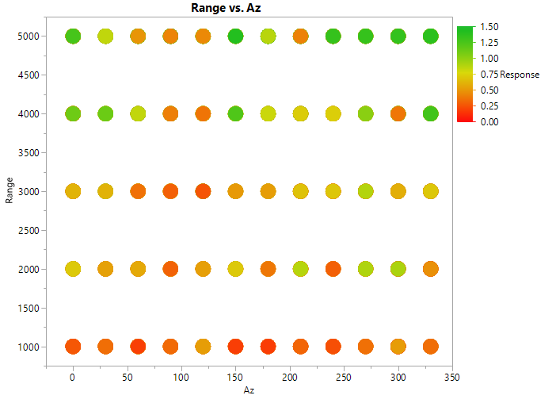 | 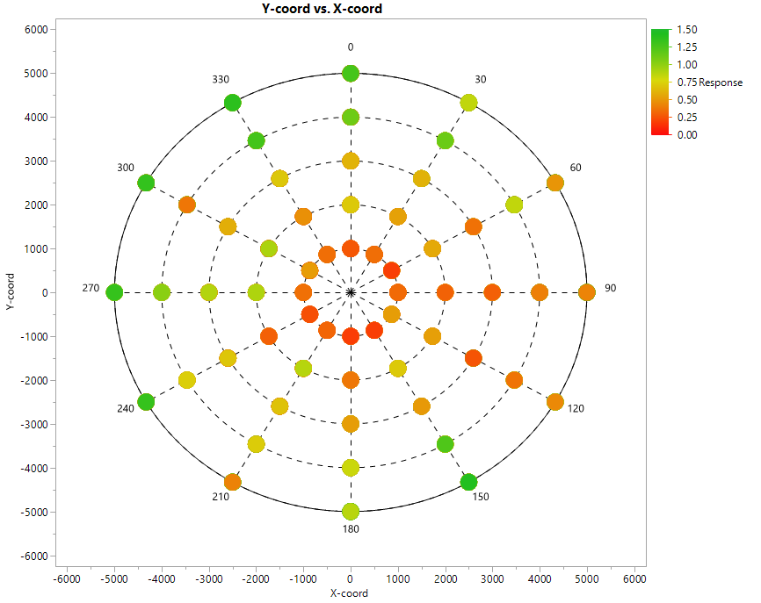
(a) | (b)
Figure 1: Response (Time) versus Azimuth and Ground Range using (a) rectanglar coordinates system and (b) polar coordinate system.
The two graphs display the same information (ground range vs. azimuth) and the marker color indicates the magnitude of the response (time), red indicating a shorter timeline and green indicating a longer timeline. The polar plot depicts more clearly how the response behaves in the factor space. Low ground range values result in shorter times, and the results are not symmetrical around the target (times tends to be larger from the right side of the target).
Polar plots are commonly used to display test results for various DoD testing. The STAT COE has developed a polar plot viewer that works in conjunction with JMP’s Graph Builder to aid in the initial exploratory data analysis. The following paper provides instructions on how to download and install the add-in, as well as provide a short tutorial on how to use it for reporting purposes.

Method

Add-in installation
In order to use this add-in, JMP must be installed on your computer. This JMP add-In can be obtained by going to the STAT COE website (https://www.afit.edu/STAT/stattools.cfm) “Polar Plot Test Design- Add-In”

Figure 2: STAT COE Website
To install the add-in, simply open the add-in (Figure 3) and JMP will make the script available under the Add-Ins menu on your toolbar.
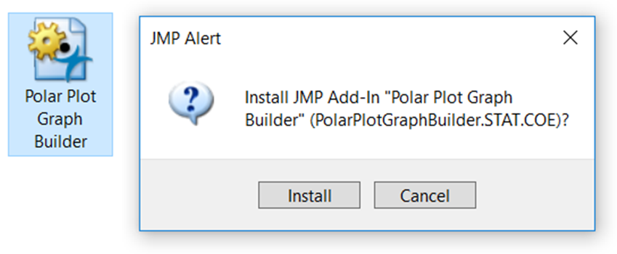
Figure 3: Installing the JMP add-in
To run the add-in, select it from the Add-Ins menu on your toolbar (Figure 4). Note: If there is no JMP data table currently open, you will be prompted to open one.
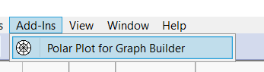
Figure 4: Add-Ins dropdown menu
Figure 5 is the Polar Plot Graph Builder dialog box.
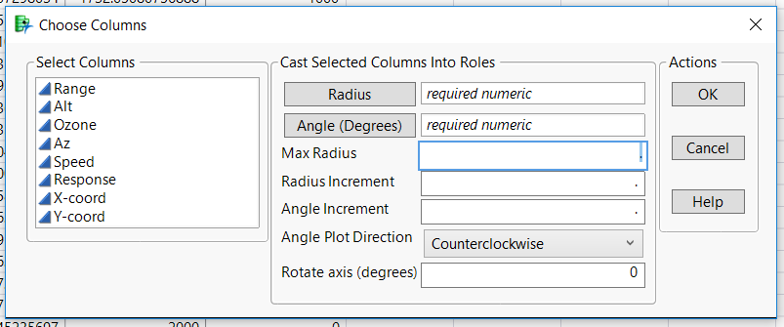
Figure 5: Polar Plot Graph Builder dialog box
A description of the required inputs is provided below.
- Radius: Column from the data table that should consist of positive numeric data.
- Angle: Column from the data table that should be positive numeric data ranging from 0-360 degrees.
- Max Radius: Maximum radius you wish to plot.
- Radius Increment: Radius increment size (should be less than maximum radius).
- Angle Increment: Angle increment size.
- Angle Plot Direction: Direction you wish to plot the angles (clockwise or counterclockwise)
- Rotate Axis (degrees): where the 0 degree angle will appear on the plot.
  - Note, this is dependent on Angle Plot Direction.
  - If plotting clockwise, a value of -90 will make the 0 degree angle appear on the top.
  - If plotting counterclockwise, a value of -90 will make the 0 degree angle appear on the bottom.

Example & Discussion
To demonstrate how to use this tool, let’s consider the following infrared countermeasure (IRCM) example. A designed experiment was created to collect time-to-go (TTG) information on a new IRCM system. To begin, download the Polar Plot Test Design from the STAT COE website (https://www.afit.edu/stat/). All data presented is notional. The data file consists of the following columns:
- Range: Ground range distance from a threat to target.
- Alt: Altitude difference from a threat to target.
- Ozone: Describes the level of atmospheric clutter in the environment.
- Az: The angular distance and direction of the threat from the target.
- Speed: Velocity of the target.
- Response: Timeline (Time-to-go).
Input the following settings into the Polar Plot Graph Builder dialog box (Figure 6):
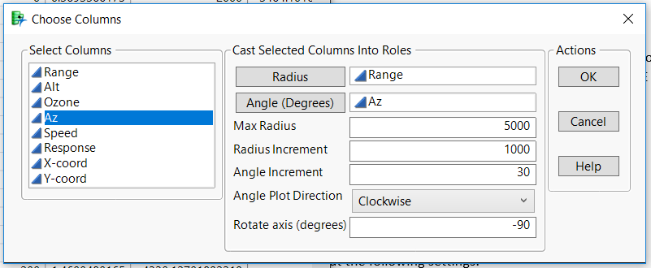
Figure 6: Polar Plot Graph Builder dialog box inputs
Click OK and the following screen will be displayed (Figure 7).
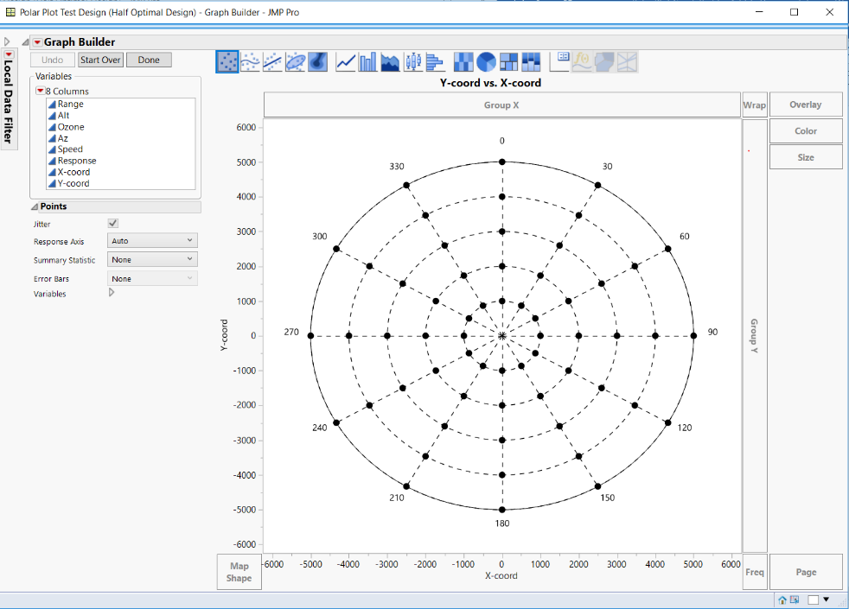
Figure 7: Initial view of polar plot
For those not familiar with the Graph Builder tool in JMP, check out JMP’s help documentation on the web (https://www.jmp.com/support/help/14/graph-builder.shtml) to learn about the numerous features and options available.
Next select Response from the column selector window in the upper left corner and drag to the “Color” box in the upper right. This will give each marker a color based on the magnitude of the response variable (Figure 8).
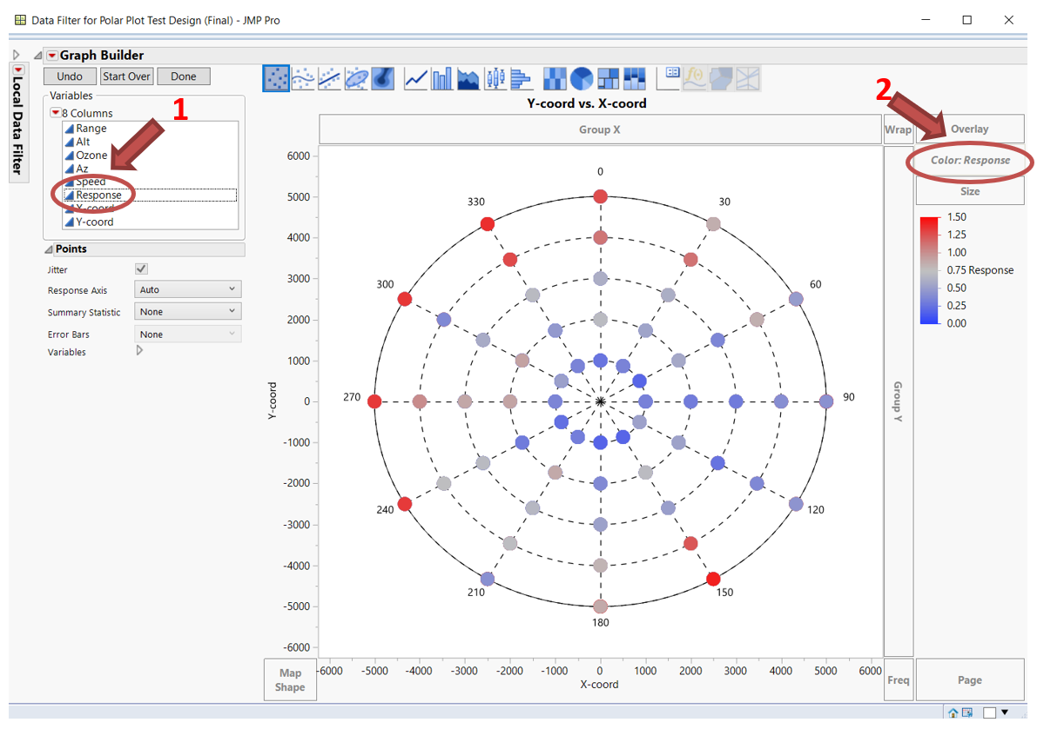
Figure 8: Polar plot graph with colored markers
In order to change the color gradient, right click on the legend and select “Gradient…”. In the new Gradient Settings dialog box, click on “Color Theme” (Figure 9).
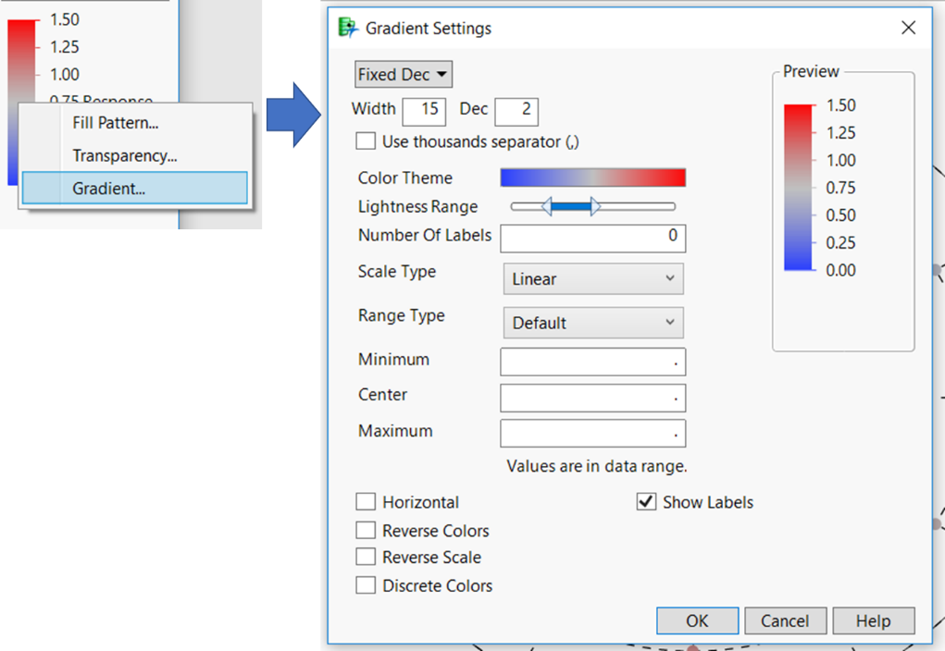
Figure 9: Change the color theme for markers
Select the last scheme under the Chromatic column (Figure 10).
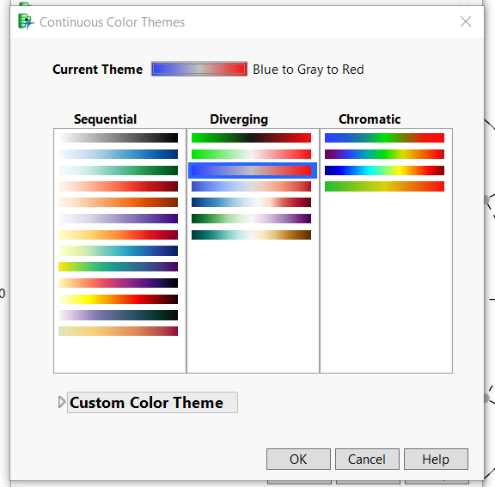
Figure 10: Select color scheme
In the Gradient Settings dialog box, check the Reverse Color box. This will make longer timelines appear more green; shorter timelines will be more red (Figure 11).
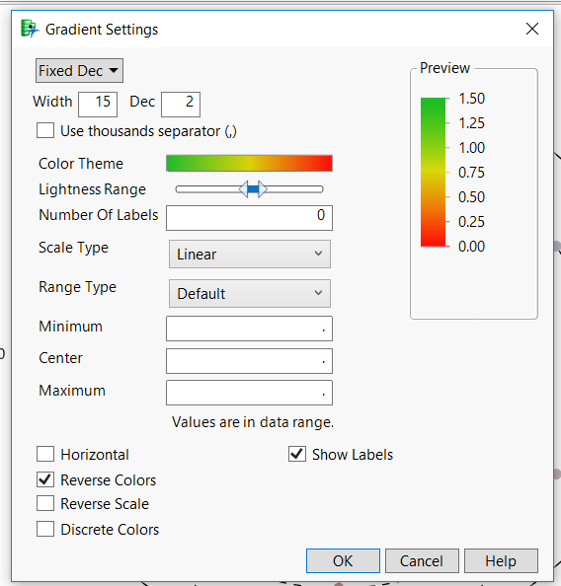
Figure 11: Gradient Settings dialog box
Click OK, and the following graph will be displayed (Figure 12). Note that in general, we have longer TTG measurements at larger ground range values.
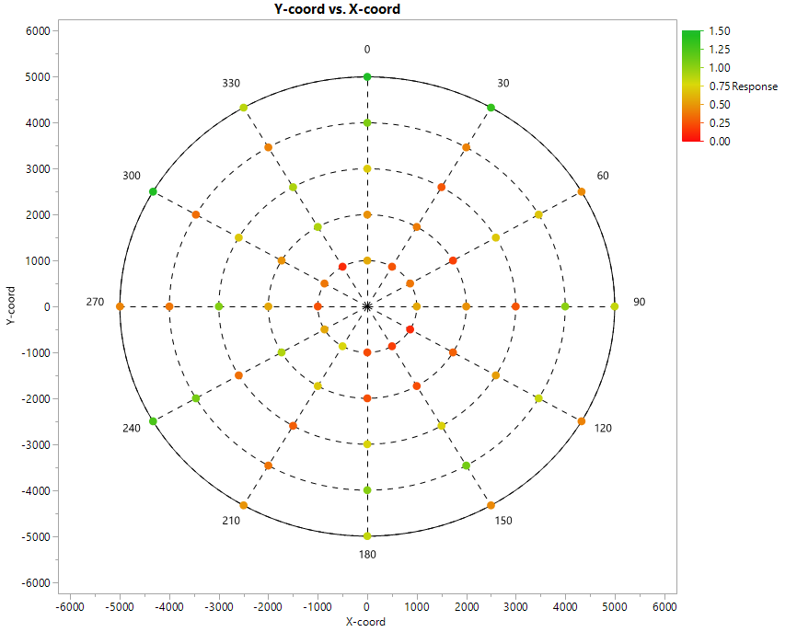
Figure 12: Polar plot graph with colored markers (red-green color scheme)
Now that the color scheme has been adjusted in the graph, consider the other factors within the table. Select “Alt” and drag to the right side of the graph into the group Y slot (Figure 13).
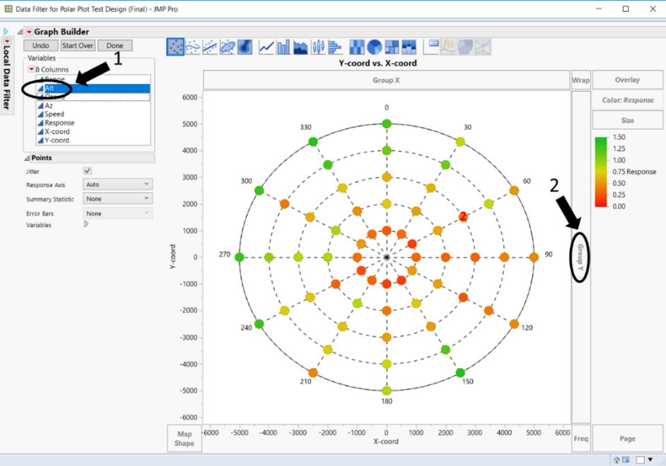
Figure 13: Adding Altitude to the graph.
This will display the following three plots (Figure 14). In this graph, you can see that there seems to be a gradual increase in time as altitude increases.
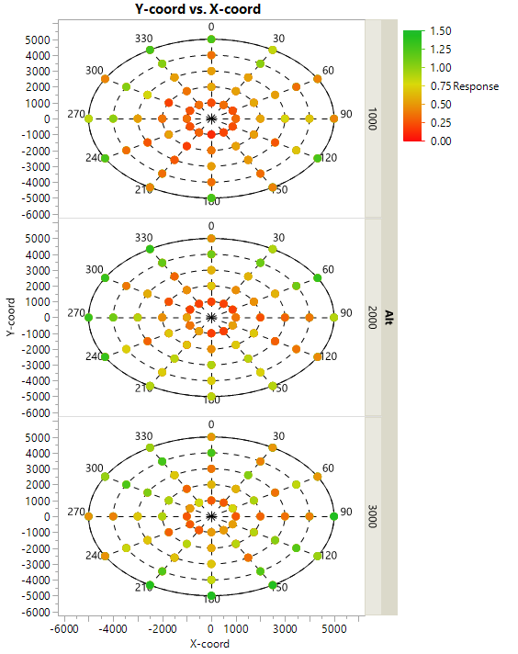
Figure 14: Polar plot for three different altitudes
Next, select “Ozone” and drag to the top of the graph into the group X slot (Figure 15).
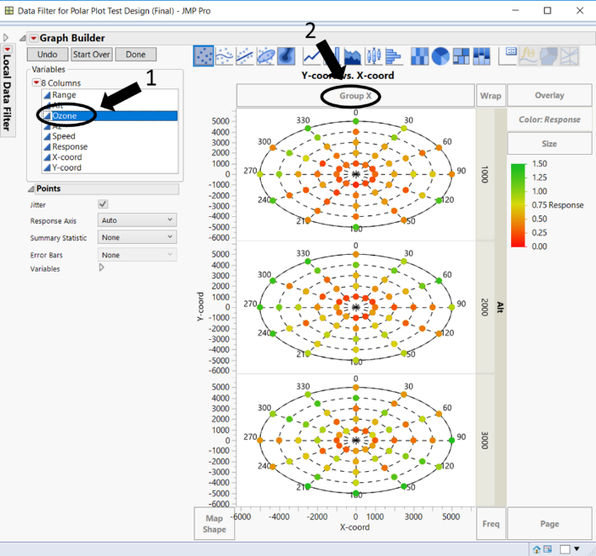
Figure 15: Adding Ozone to the graph
This will display the following graph (Figure 16). The visual shows that Ozone seems to have a large linear effect on the response.
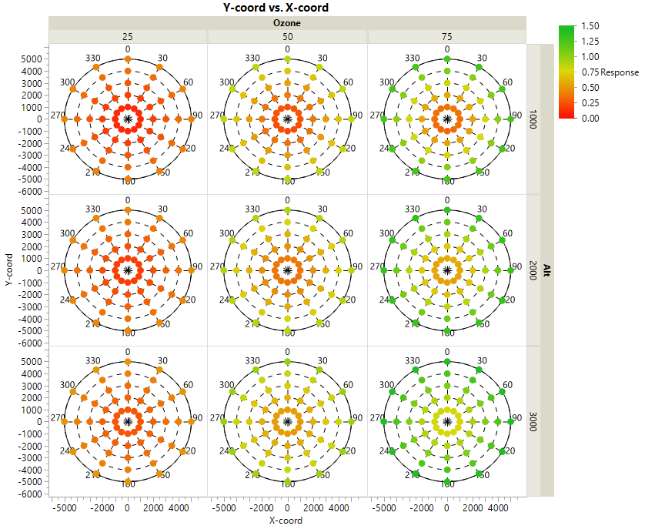
Figure 16: Polar plots for each combination of Altitude and Ozone levels
Next, select “Speed” and drag to the bottom right of the graph into the page slot (Figure 17).
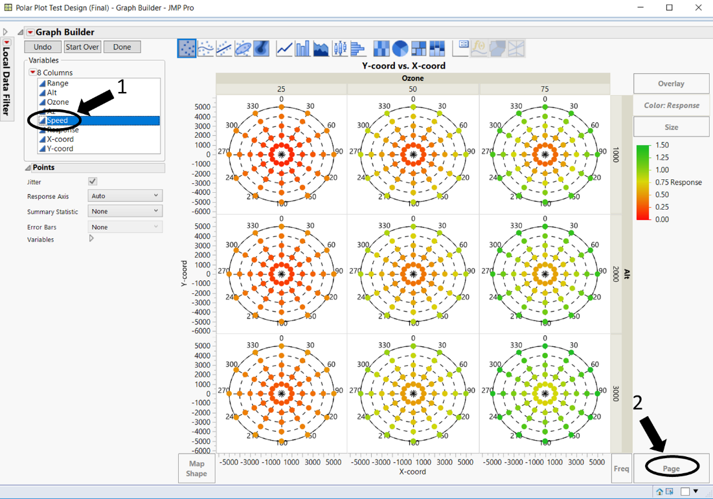
Figure 17: Adding Speed to the graph.
This will create three groups of plots; there is one group for each of the speed settings. Speed seems to have little to no effect on performance (Figure 18).
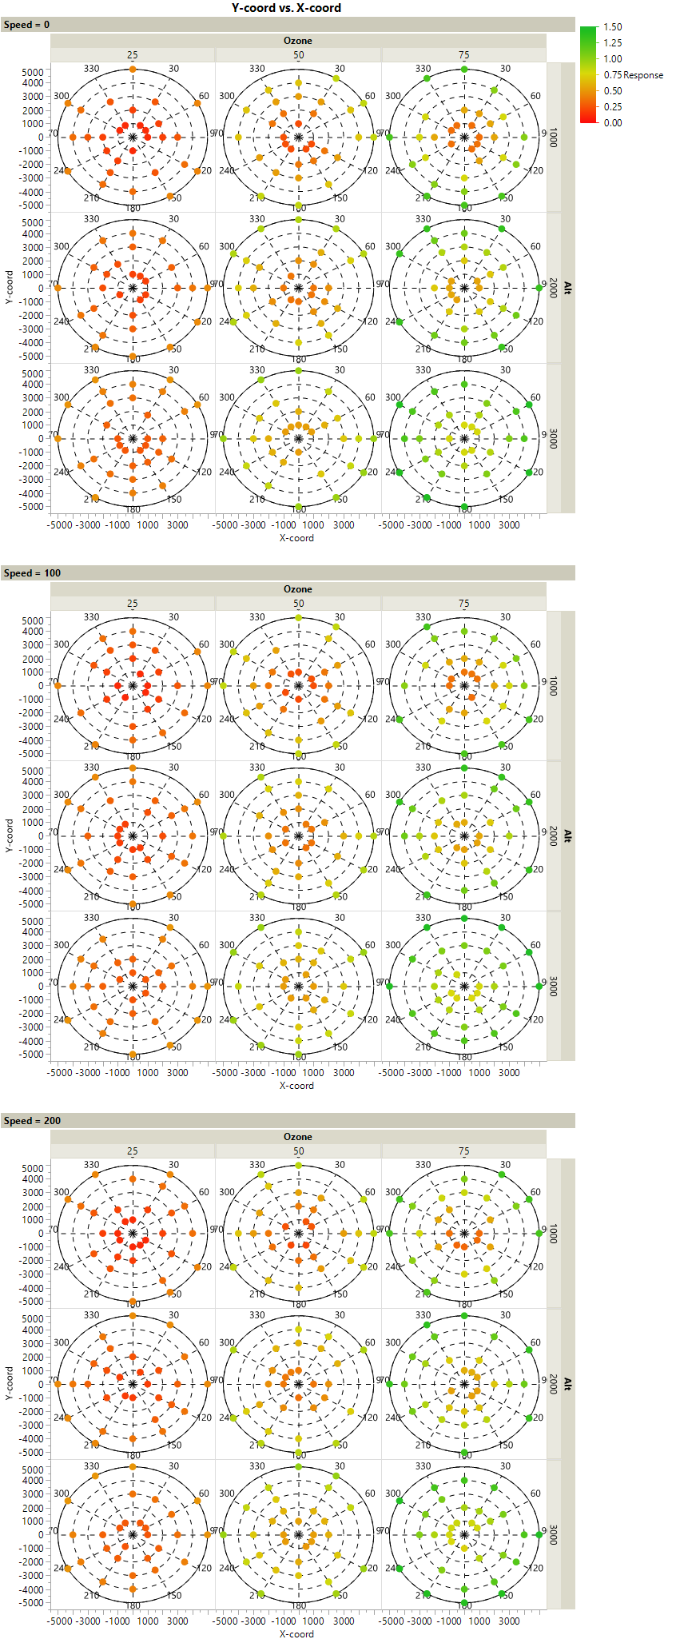
Speed=0

Speed=100

Speed=200

Figure 18: Polar plots for each combination of Altitude, Ozone, and Speed levels
A lot can be gleaned from simply visualizing the data; however, this is not meant to be a substitute for further analysis such as ANOVA and regression. This preliminary summary helps establish an initial guess of which underlying model may be a good fit for the data. The response (TTG) seems to linearly increase with changes in Range, Altitude, and Ozone. Therefore, one can assume a linear or a low order polynomial model with main effects and two-factor interactions would be sufficient to model the response.
Within the JMP toolbar, select Analyze, Fit Model. Select the five factors (Range, Alt, Ozone, Az, Speed). Go to the Macros button at the bottom of the Construct Model Effects, select “Factorial to degree”; this will specify that we wish to fit a main effects and two-factor interaction model (figure 19).
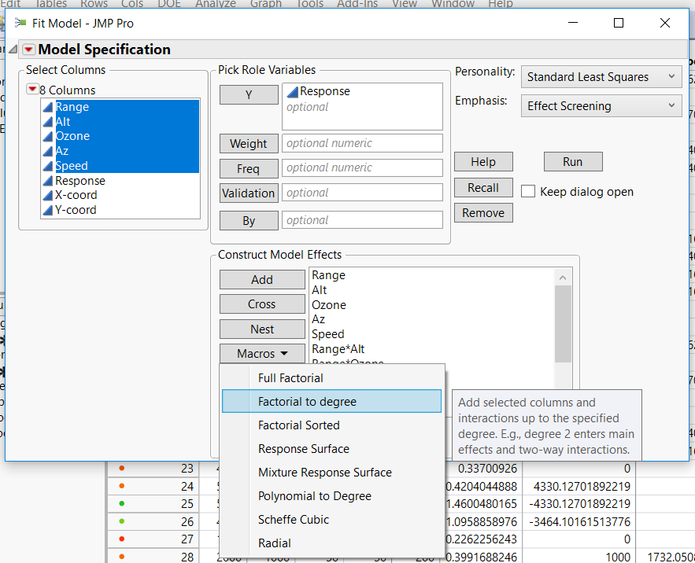
Figure 19: Fitting a main effect and two-factor interaction model in JMP
After specifying the model, select “Run.” A “Fit Model” window will appear with the results of the regression analysis (Figure 20).

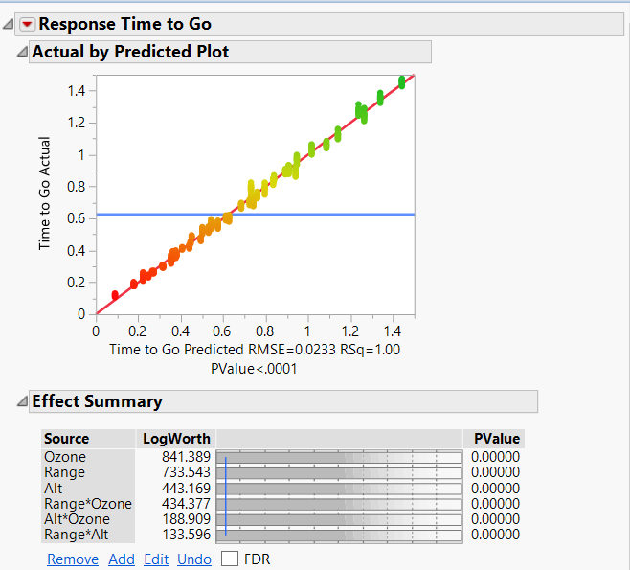
Figure 20: TTG Actual vs. TTG Predicted graph.
The Time to Go Actual vs. Time to Go Predicted graph shows that a linear model with following terms and parameter estimates (Figure 21) provides an almost perfect prediction (RSq=1.00) of TTG.
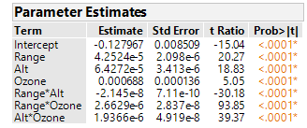
Figure 21: Parameter estimates for each model term.
The magnitude of the parameter estimates describe the slope (influence) a factor has on the response (TTG). The Prediction Profiler below (Figure 22) is a visual representation of the TTG response in the three-factor space. The slope for Ozone is the largest (0.000688) followed by Range (4.2524e-5). Note that there are several 2-factor interactions that are statistically significant. These interactions can be difficult to identify using visualization tools.
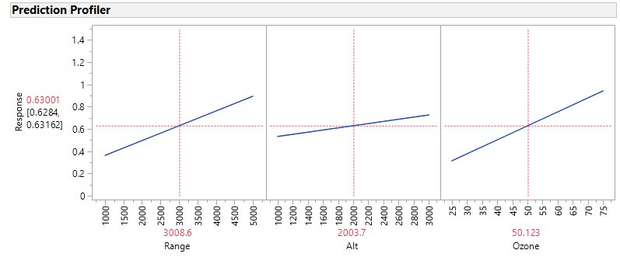
Figure 22: Prediction profiler for TTG response.
The regression analysis provides a mathematical model of what was observed visually with the polar plots. Range and Ozone influence TTG more than Altitude and Speed has little to no effect on TTG. One of the benefits of the mathematical model is that we can predict the performance of untested factor settings (scenarios).

Conclusion
This document served as a tutorial on how to install and use the Polar Plot Add-in tool developed by the STAT COE. The tool was applied to an exploratory data analysis example of an IRCM system. The analysis demonstrates how using visualization tools, particular those that mimic the natural factor space, can aid practitioners in estimating the underlying mathematical model that best fits the data.

