Developing Test Designs with Constrained Factors for Military Fast Jet Life Support Systems

Case Study
  - Authored by: Steven Thorsen, PhD
  - Sarah Burke, PhD
Andrew Klein
Darryl Ahner, PhD
  - 20 August 2019


The goal of the STAT COE is to assist in developing rigorous, defensible test strategies to more effectively quantify and characterize system performance and provide information that reduces risk. This and other COE products are available at www.afit.edu/STAT.
Table of Contents

Executive Summary 2
Introduction 2
Subtitle 2
Background 2
Subtitle 2
Method 3
Subtitle 3
Expected Results & Discussion 3
Subtitle 3
Further Subtitle 3
Conclusion 3
References 3

Abstract
Recent experiences testing one of the U.S. military’s fast jet life support systems serves as a case study to create test designs involving constrained factors. The study discusses lessons learned during LSS testing, applicable to all practitioners of scientific test and analysis techniques. The authors conduct an analysis to determine a test region with factors pertinent to modeling human breathing and breathing machines as part of the laboratory setup. A comparison of government and industry laboratory tests with governing documentation is made, along with a proposal for determining an appropriate test region for tests involving human breathing as a factor.
Keywords: design of experiments, local control, OBOGS, optimal design, scientific test and analysis techniques

Introduction
Recently, fast jets in the U.S. inventory that rely upon on-board oxygen generating systems (OBOGS) to provide adequate levels of oxygen to pilots suddenly appeared to have an increasing number of unexplained physiological episodes (PEs) occurring among aircrew. Mounting concern regarding the cause of the PEs warranted urgent investigation to discover root causes before there could be materiel or personnel losses. Pilots of one fast jet variant reported symptoms consistent with hypoxia, leading many involved with the investigation to suspect that low oxygen levels were to blame and were the result of issues with the OBOGS. Medical debriefings confirmed “hypoxia-like” symptoms, but none of the episodes had caused loss of consciousness or loss of aircraft. However, pilot reports increased in both frequency and severity. There were other serious possible causes of the PEs, including a possible air supply contamination sourced either within the system or from the external environment, possible breathing restrictions, and more. The root cause(s) could be systemic, but the most important condition to rule out from the onset was hypoxia; this was an especially critical concern because all of the recorded in-flight data showed that the oxygen levels provided to the pilots were adequate and backup systems functioned perfectly in all cases. The leadership for this fast jet variant’s program office requested the Scientific Test and Analysis Techniques (STAT) Center of Excellence (COE) (https://www.afit.edu/STAT/) assist with testing the fast jet life support systems (LSSs) from both incident and non-incident aircraft, using a rigorous scientific approach emphasizing the use of design of experiments (DOE) (Montgomery, 2017) to identify causes of the PEs.
Figure 1 shows the sample structure of the OBOGS of an aircraft. The initial focus of testing was directed at the LSS OBOGS performance and also included studies of the oxygen mask and breathing regulator.
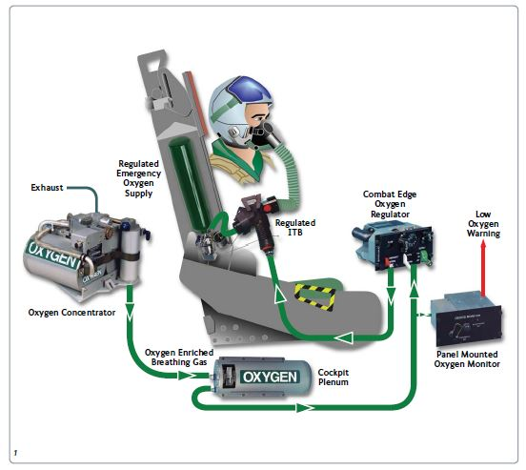
Figure 1: Example of OBOGS for an aircraft. Source: Cobham
While the program leadership directive got us in the door as a part of the team, we faced the usual challenges of having to prove our worth to a test team used to doing things quite differently, which lacked both classical and modern DOE approaches to testing. The lab we worked with had written a significant portion of a test plan before we were brought on the team. We discovered early on the test team was under severe time pressure to get results fast. As a result, we focused our initial efforts on designing efficient, randomized test designs with replicates using factors solely identified by the lab. Unfortunately, we failed to sufficiently question the lab setup to ensure that extraneous system noise was minimized. In particular, we were told one of the identified factors, breathing profile, had six discrete levels, four of which were relevant to these tests. The lab indicated these levels were derived from a set of required guidance in a NATO specification referred to as an “Air Standard.” The program office lead engineer accepted this as well, yielding deference to the decades of experience of the lab test personnel. However, during our work with the lab, we discovered two constraining issues with the breathing profile factor. It took time digging into the research, discovering approximating formulas for the set of factors that actually made up the breathing profile, and conducting an analysis that ultimately revealed the testing of the LSS was not being done well for PE root cause determination. In fact, the LSS had likely never been tested thoroughly during acceptance testing, having missed some important factor regions, both by the developing contractor and by the qualification testing laboratory. Since all fast jets adhere to the same testing standard, it is doubtful any such acceptance testing has been adequate to establish the LSSs are safe-to-fly across the expected performance envelope, and this poses a significant unrealized threat to many U.S. Air Force missions, most notably the training of new pilots.
This paper serves as a case study and lessons learned documenting what was flawed in part of the original approach to root cause testing of an LSS OBOGS concentrator, particularly the experimental setup of an adequate operational environment for the tests. We attempt to show how a DOE practitioner could do better in similar future testing, both in the planning and design. We use this case study to demonstrate the necessity of diligence in researching factor levels and knowing how to deal with constrained factors. We first provide some background on the use of DOE. We then introduce the background of our test for the LSS OBOGS. Within the case study we examine several lessons learned based upon 1) the DOE principle of local control, 2) the creation of an appropriate DOE test designs involving factor constraints, and 3) logical and visual comparisons of military standard guidance with the efforts of three participating laboratories. Following this we have some final discussion points involving the factors and a conclusion.

Background
Scientific test and analysis techniques (STAT) are deliberate, methodical processes and techniques that create traceability from capabilities (or requirements) to decisions (DODI 5000.02, 2017). STAT helps identify and quantify the risk associated with different test methods (e.g., DOE, reliability, or observational studies) and helps practitioners develop efficient, rigorous test strategies that will yield defensible results. Repeated use of STAT is a progressive, sequential testing approach that carefully leverages past test information and informs the systems engineering process of when a system or system integration should be redesigned.
DOE is a statistical test methodology in which the values of the inputs are purposefully manipulated by the experimenter in order to understand causal relationships between the inputs and the response(s), when these relationships exist. DOE classically focuses on three fundamental principles of execution: randomization, replication, and local control of variation. Of these three principles, typically the questions of local control are most difficult to integrate in the test design and during test execution. DOE provides an efficient and effective test strategy to characterize performance of a system, find optimal conditions of a process, or to identify causes of failures. However, constructing a test design requires tremendous systematic planning so the desired information is learned from the test. In addition to identifying the objective of the test, the response(s) to measure, and the factors that you can control in a test, we must also identify test constraints. Test constraints can come in many forms: budgetary constraints, time constraints, and factor space constraints. Budgetary constraints often put an upper limit on the number of feasible test runs. Time constraints typically mean only a certain number of test runs can be completed in a workday; therefore, the design must account for testing that must be completed over several days. Factor space constraints mean that for various reasons, areas of the design space are neither feasible nor meaningful for testing. In other cases, a factor constraint may occur when two or more factors have a functional relationship that can be properly defined and exploited as either linear or non-linear constraints. This relationship must be taken into account when selecting design points so that invalid conditions are not included in the test. The test team must often do crucial research to have a thorough understanding of the factors to discover these often-underlying relationships. By gaining this knowledge, practitioners are able to design the best test given the factor constraints. This design should minimize the effects of any inherently correlated factors to provide greater understanding of the response and answer the test objectives.

When there are no known underlying relationships of the factors and few constraints, executing a classical design such as a fractional factorial design, often provides what is necessary and sufficient for an efficient experiment; however, when there are test constraints, especially in the number of test points, practitioners turn to computer-generated optimal designs. Optimal designs allow practitioners to tailor a design to a specific test so that it incorporates test constraints, such as budgetary and factor constraints to account for any correlation among model terms. For example, if there are known factor combinations that will not provide valid test results, an optimal design can be generated to avoid these combinations. To build an optimal design, the user must provide detailed information because each optimal design is customized for a particular test scenario. In particular, the user must specify the factors, levels, desired empirical model during the analysis phase, factor constraints, number of runs, and design criterion.
There is a reason that planning a test should follow the Pareto principle; planning takes roughly 80% of the time involved in an entire test process. Test planning requires understanding the system under test and typically involves multiple consultations with system experts in an iterative fashion. This requires due diligence, so that as the test planning process unfolds, the design of a test seems to suggest itself and minimizes complications allowing a practitioner to derive a correct analysis from the collected data.

Case Study
The STAT COE was engaged to assist planning, executing, and analyzing tests for a particular fast jet LSS. We encountered several types of test constraints during the project. Due to pressure to begin testing as soon as possible, however, we did not thoroughly question the lab’s setup. We did not engage enough resources in determining the span of local control of factors. We accepted at face value the lab leadership’s cumulative experience in testing and built an initial set of test designs based upon the factors the lab leadership indicated they were comfortable measuring (from a successful execution viewpoint) and the levels associated with them. We discovered later the lab setup was not ideal to truly understand how the LSS performance varies across aircrew “breathing space” conditions. In the following section, we discuss in detail some key issues encountered during our testing of LSSs and provide ideas for how to handle constrained design space problems in future lab testing of LSSs.
Unexplained PEs suggested there may be an issue with the LSS. In particular, low oxygen warning lights were triggered under various conditions during live flights and aircrew symptoms followed. It is key to note that in the vast majority of cases, the aircrew symptoms were subsequent to an electro-mechanical warning.
Unmanned breathing studies, tests, or experiments typically rely on a machine that simulates breathing in humans. The machines do not perfectly emulate the dynamics of all human breathing phenomenology present when flying in a military aircraft; however, they do emulate steady-state conditions well and are easily manipulated for local control of variation. The objective of the study was to determine the cause(s) (if any) of failures in the LSS across the operational space. The lab measures the oxygen levels output by the LSS, while purposefully and repeatedly manipulating several factors. Among many follow-on analyses, the analysts compare this recorded data to the required levels to support the pilot.
The test team identified an initial set of factors of interest for the experiment: cabin altitude, flight altitude, inlet pressure, and breathing profile. Cabin altitude and flight altitude were highly correlated to each other according to a well-understood oxygen schedule; ultimately, cabin altitude was used as the primary altitude factor. Inlet pressure, the pressure at the OBOGS, was a continuous factor. Breathing profile was pre-determined by the lab and treated as a categorical factor. In reality, the breathing profile was actually constructed by two continuous variables (breathing rate and peak flow), which were recorded during testing. Breathing rate is the rate of inspiration/expiration cycles and is measured by breaths per minute (BPM). Peak flow is the maximum rate at which air mass is inspired in a single breath and is measured in liters per minute (LPM). Breathing profile had four levels that, according to the lab leadership, could not be changed and which were commonly used in lab testing. We were told this was how the lab was set up and that it followed the “Air Standard” commonly used in U.S. Air Force testing. Table 1 shows how the four levels of breathing profile relate to these two variables for our lab, which we label as Lab A. The final column lists an additional variable, tidal volume, which we discuss later.
Table 1: Breathing Profile Level Description
We proceeded with the study given the lab setup of breathing profiles and created designs using the lab’s definition of the aircrew breathing space. While we did learn valuable information about the performance of the LSS under various conditions, the test results were limited because breathing profile was treated as a categorical factor. Interpolation between breathing profiles was not possible, so we could only draw valid conclusions about the LSS performance at the tested breathing profile combinations. Furthermore, modeling breathing rate and peak flow in place of breathing profile was not appropriate because of the correlation that existed between these two variables in the tested conditions. Figure 2 shows that peak flow and breathing rate were not orthogonal in the test design. In fact, the linear correlation coefficient between the model term estimates for these two factors was 0.78. This high level of correlation does not provide a clear indication of which of these breathing factors actually has an effect on the LSS performance.

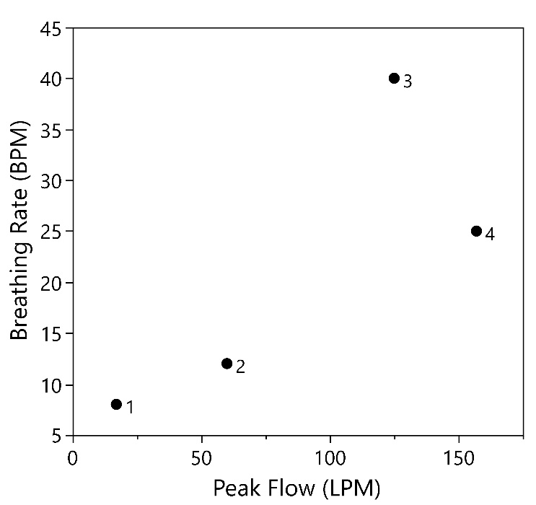
Figure 2: Lab A Breathing profile by breathing rate and peak flow

Principle of Local Control: Finding Appropriate Ranges for Breathing Factors
After further research (Ernsting, et al., 2003) we concluded there are actually three important factors that make up aircrew “breathing space.” These factors capture the necessary and feasible range of human breathing. In addition to breathing rate and peak flow, tidal volume is also a fundamental variable that describes human breathing patterns. Tidal volume defines the volume of air inspired in a single breath during steady breathing and is measured in liters (L). The lab eventually presented an equation that relates these three variables under the assumptions of steady-state breathing:
$$Tidal Volume=\frac{Peak Flow}{π Breathing Rate}$$ | (1)
The approximating equation is derived from an estimate of a sinusoidal breath as detailed in Figure 3. The tidal volume is represented by the area under the curve (shaded region in Figure 3).
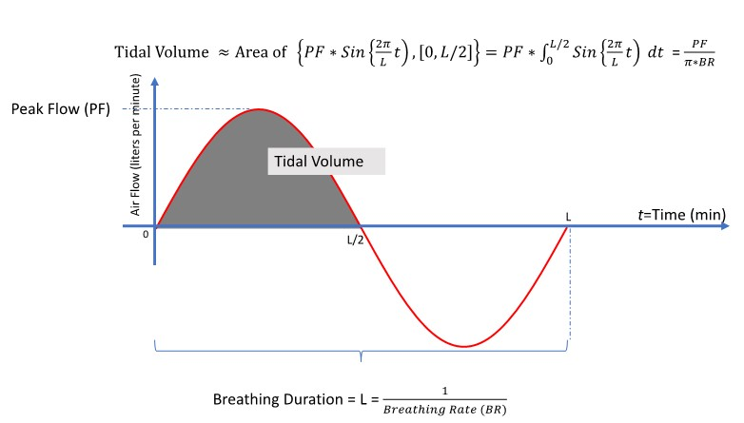
Figure 3. Deriving the Approximating Function for Machine Breathing as a Model for Machine Breathing Calculations
These three nonlinearly related factors impose a constraint on the use of classical designs for the LSS test. We expect some level of correlation to be present in any design we may use for an experiment on the LSS that involves these three factors. There is no completely orthogonal design that can efficiently and effectively cover the design space; however, we can use an optimal design to maximize the information learned in the test by specifying the disallowed factor conditions.
Furthermore, we were initially told by lab leadership that the breathing profile was determined by the breathing rate and peak flow. However, the breathing machines used in the lab testing manipulate the breathing rate and tidal volume, and not the peak flow. Peak flow is the dependent factor in the lab setup.
Tidal volume has minimum and maximum safety limits as defined by the military standard MIL-STD-3050 (Department of Defense Design Criteria Standard, 2015) hereafter referred to as MILSTD and the “Air Standard,” AIR-STD-61-101-2B (Air Standardization Coordinating Committee, 1982), hereafter referred to as AIRSTD. In particular, tidal volume should range between 0.5 and 2.5 L, representing the safe range of human tidal volume performance as listed in the MILSTD.

The MILSTD establishes the minimum design criteria for an aircraft crew breathing system using OBOGS and lists Appendix C, “Government Verification and Validation of Crew Breathing System Using OBOGS,” as a mandatory part of this standard, shown in Table 2. The lab we worked with (denoted Lab A) provided four breathing profiles, as previously indicated in Table 1. Only two of these breathing profiles, profiles 1 and 3, overlap with those from Appendix C in the MILSTD (Table 2). The MILSTD further states the appendix is intended for compliance and identifies a “minimum set of required and suggested tests but not every possible test.” Further, it is suggested that these test points must be part of the test. Although these six test points cover the three breathing space factors in a continuous manner, the tests based on this guidance commonly treat the breathing profiles in Table 2 as one categorical factor, called “breathing profile,” with six levels. This severely limits the amount of inference any experiment can accomplish when following the letter and not the spirit of this guidance. In addition, to achieve sufficient statistical power to assess the effect of breathing profile, many more test runs would be required as a result of treating breathing profile as a categorical factor. Further, it is also not possible to clearly distinguish the effects of peak flow, breathing rate, and tidal volume on the LSS performance if the breathing space is treated as a single categorical factor. Using computer software, however, we can instead construct an optimal design that incorporates the nonlinear constraints defined for these three continuous factors. While there will always be some level of confounding due to the relationship among these factors, we can limit the effect confounding will have in the design and analysis.

Table 2: MIL-STD-3050 mandatory test points for verification and validation tests (Appendix C)

The AIRSTD, entitled, “Development Test and Evaluation of Aircraft Oxygen Delivery Systems,” focuses on more than just OBOGS systems. Table 2 of the document, recreated in Table 3, specifies workloads and gives us a comparison set of factor levels for our LSS test. The AIRSTD provides clear orthogonal ranges for peak flow and breathing rate; however, the standard does not deliver the constraint upon the range of tidal volume. We count this as a shortcoming perhaps born out of the antiquity of the document.
Table 3: AIRSTD Workload Definitions
The MILSTD deliberately sets limits to what is considered values of tidal volume safe for humans; the AIRSTD does not address tidal volume and has a different set of ranges for the three breathing space variables. From Table 2, we elicited valid ranges for the breathing space factors. The breathing factors are typically only a few of the factors under consideration with an LSS test. Other factors include cabin altitude (possibly flight altitude as well), OBOGS inlet pressure, OBOGS serial number (for OBOGS to OBOGS comparisons), plenum volume, climb rate, dive rate, and others (to include other equipment attached to OBOGS including the regulator with its many possible factors and the mask with its possible factors, such as mask cavity volume).
Table 4 summarizes a few of the factors of interest in the initial LSS testing. The approximating formula (Equation 1) does a good job on getting the proper tidal volume per the table except for Profile 1, where the tidal volume is calculated to be 0.67 L vice the 0.5 L listed. It’s not clear whether this is an error in the MILSTD or not.
Table 4: Factors and Levels

Creating a Test Design with Factor Constraints
Given the information discovered on the breathing space variables, we constructed an optimal test design with the defined factor constraints using the statistical software JMP (V. 13). The response of interest in this experiment was the oxygen percentage, representing the amount of oxygen delivered to the pilot. All four factors are continuous and “easy to change,” meaning that all runs in the test can be fully randomized.
The MILSTD defines the minimum and maximum safe values of human tidal volume to be 0.5 and 2.5 L, respectively. Equation 2 shows the inequality that must hold to have a feasible factor space for the continuous breathing factors.
$$0.5≤Tidal Volume=\frac{Peak Flow}{π Breathing Rate}≤2.5$$ | (2)
Since the lab actually controls breathing rate and tidal volume during their testing, Equation 2 should be rearranged into constraints around the peak flow using the minimum and maximum values of peak flow [17,258]:
$$17≤Peak Flow=π*Tidal Volume*Breathing Rate≤258$$ | (3)

To generate an optimal design with factor constraints, we must specify the disallowed conditions in the design space. Therefore, we must specify that the peak flow is not less than 17 or greater than 258. The nonlinear constraints for these three factors is shown in Figure 4.
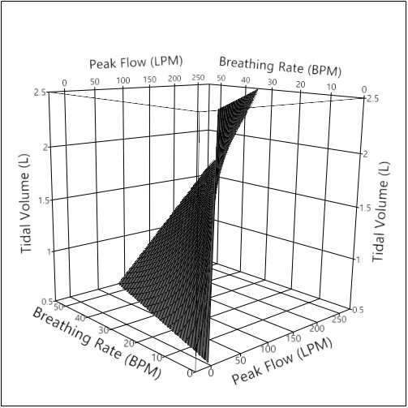
Figure 4. Three-Dimensional Render of Equation 2.
With the factor constraints specified, the next step is to define the desired linear regression model. Because this is a screening experiment, we focus on identifying the important factor effects and therefore fit a model for main effects and two-factor interactions for the four key factors:
$$y=β_{0}+β_{1}x_{1}+β_{2}x_{2}+β_{3}x_{3}+β_{4}x_{4}+β_{12}x_{1}x_{2}+β_{13}x_{1}x_{3}+β_{14}x_{1}x_{4}+β_{23}x_{2}x_{3}+β_{24}x_{2}x_{4}+βx_{3}x_{4}+ε_{i}$$
We will later add in center points to allow a test for curvature in the response, which will help determine whether quadratic terms for any of the factors are also necessary in the model.
The desired model has 11 terms including the intercept; therefore, the minimum number of test points is 11, which would allow us to estimate each model term, but not perform any statistical inference on their significance. We investigated several designs of various sizes to choose the most effective and efficient design for the experiment. After each design was created, we added four center points to provide a test for curvature.
Ultimately, we compared four test designs (with sample sizes of 16, 20, 24, and 28). We considered the power (with a target value of 80% power at a signal-to-noise ratio of 2 and significance level of 5%) and the amount of confounding in the resulting design. Because the breathing variables are related to each other, the optimal design for this experiment will never be completely orthogonal. However, an optimal design will help minimize any confounding. Figure 5 displays the power for each model term of the four designs. The estimated power for the breathing variables (tidal volume and breathing rate) is always lower than the other two factors because of the factor constraint. The 24-run design estimates at least 80% power for all model terms of interest; the 20-run design estimates sufficient power for the model terms not including the breathing space factors. The 28-run design likely has more runs than necessary to meet our target power goal.
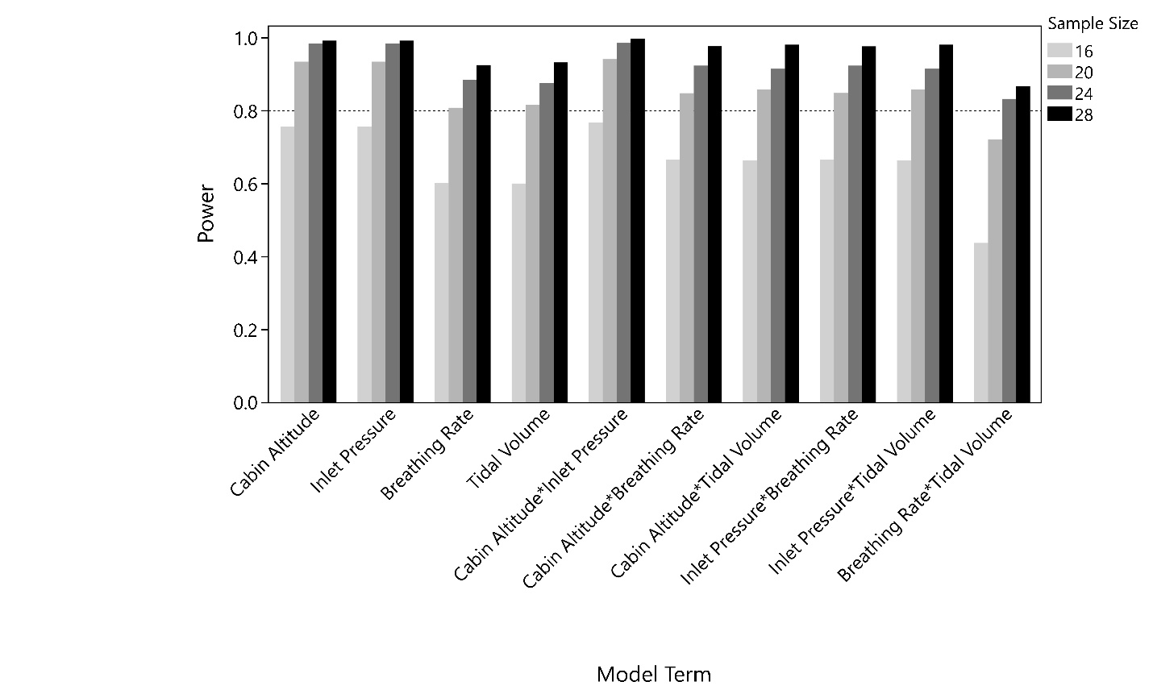
Figure 5. Power comparison by design sample size
The color map of correlations in JMP, illustrated in Figure 6, provides an easy visual aid to quickly ascertain the amount of confounding in a test design. Each row and column represent a model term. The boxes indicate the amount of confounding between model terms. A black box indicates that two model terms are completely confounded with each other, meaning it is impossible to distinguish which term actually has an effect on the response. The lightest gray indicates that the two model terms are orthogonal (i.e., we can isolate which model term has an effect on the response). Any shade of gray in between indicates some level of confounding between model terms; the lighter the gray the better. Figure 6 shows the color map of correlations for the four designs under consideration. For example, the first four rows show how main effects are aliased with other main effects (across the first four columns) and two factor interactions (across the last six columns). The goal is to have the main effects as clear as possible to ensure the effects of each factor can be clearly analyzed. Across all the designs, there is always confounding between tidal volume and breathing rate (as well as interactions with those factors) as shown by the shaded boxes in the off-diagonal positions in the figure.
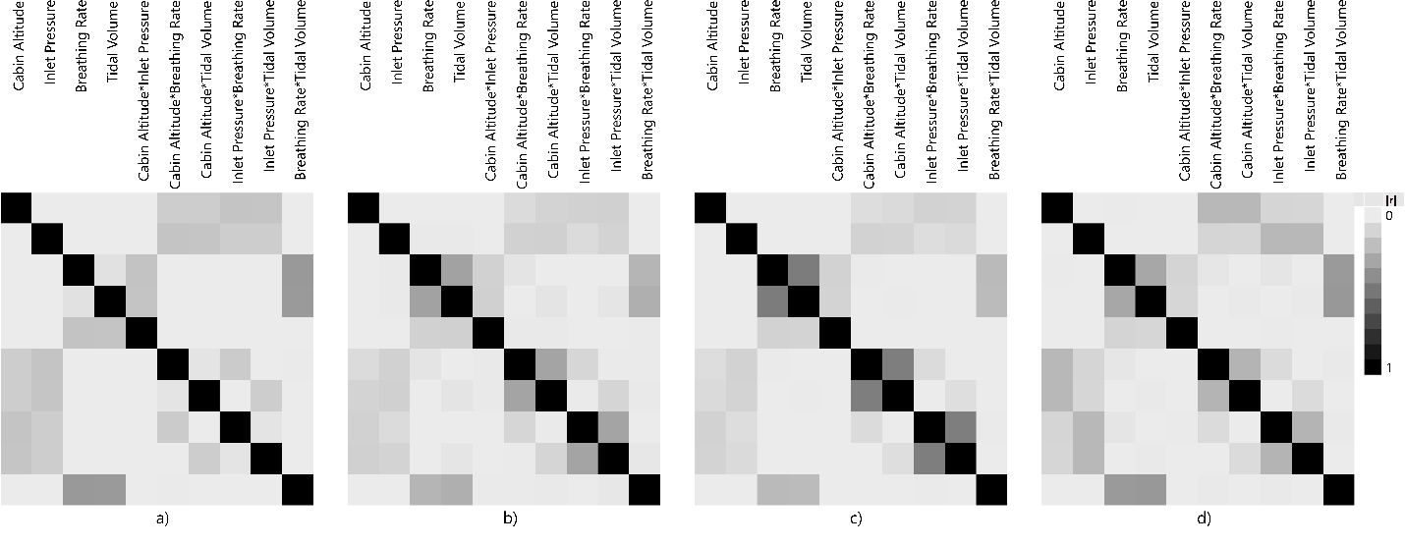
Figure 6. Color map of correlations for designs with a) 16 runs, b) 20 runs, c) 24 runs, and d) 28 runs
Consider the 24-run design shown in the pairwise scatterplot in Figure 7. All four factors of interest (cabin altitude, inlet pressure, tidal volume, and breathing rate) are shown in the figure. Peak flow has also been included to show the relationships among the breathing space variables, although peak flow is not directly controllable by the lab. The scatterplot in the top left shows the test points between cabin altitude and inlet pressure. Because these factors are not constrained, these factors are orthogonal in the test matrix. Compare this to the relationship between peak flow and tidal volume (the plot in the bottom right of Figure 7). The upper left corner between peak flow and tidal volume does not have test points. Similarly, there are no test points in the upper right corner between breathing rate and tidal volume. These areas make up the disallowed region for the breathing space variables.
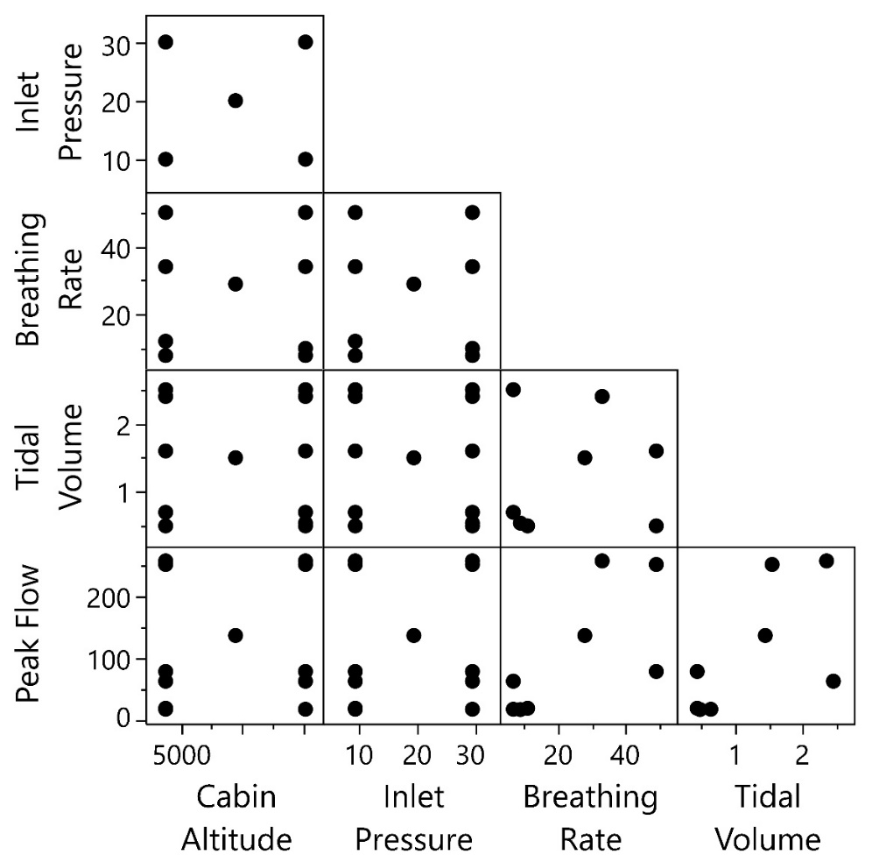
Figure 7: Pairwise Scatterplots of factors in 24-run test design
Optimal designs are generated using a search algorithm. At each step in the algorithm, the level of a factor of one of the test points is considered. If changing the level of that factor improves the overall design, that test point is changed. Because the method uses a computer algorithm, the final design can contain some design points that may not be convenient to be executed in practice. For example, the level of a factor may have many decimal places. In this example, there were instances where a few test points had very similar levels for the breathing space factors but were not quite the same (see Figure 8a), thus requiring a unique test setup for closely aligned test points. Because the breathing space factors have to be added as profiles within the lab setup, fewer of these unique factor levels would facilitate quicker lab test execution. Therefore, we collapsed a few test points to simplify the test design (Figure 8b). We then re-evaluated the design to ensure its properties were still acceptable. Note that this type of design manipulation should be done only when absolutely necessary.
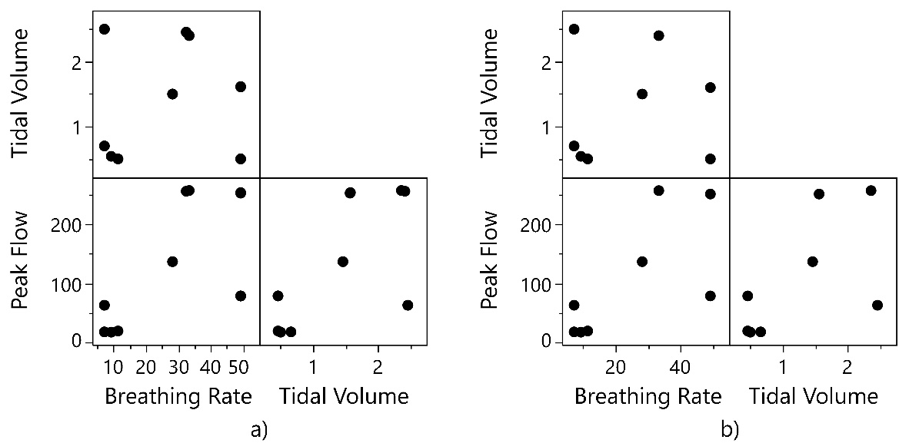
Figure 8: a) Original test points for breathing space variables; b) collapsed test points
Figure 9 compares the peak flow-breathing rate region carefully constructed from the breathing profile test points given in Appendix C of the MILSTD (Table 2) with the orthogonal groupings of regions suggested in the AIRSTD. The diamonds in the figure represent the six profiles recommended in the MILSTD, while the rectangles represent four workload areas described in the AIRSTD. It is clear the two regions do not align well. The MILSTD has zero test points in the “Light Workload” region and has two test points outside of the workload regions defined by the AIRSTD guidance. This region does not properly synthesize all of what is contained in the guidance and only applies what is given in the Appendix alone. This is a clear case where the appendix, while trying to simplify the process leading to the best test points, contained an error in its simplification, likely because it did not consider the constraining action of the tidal volume range of human breathability.
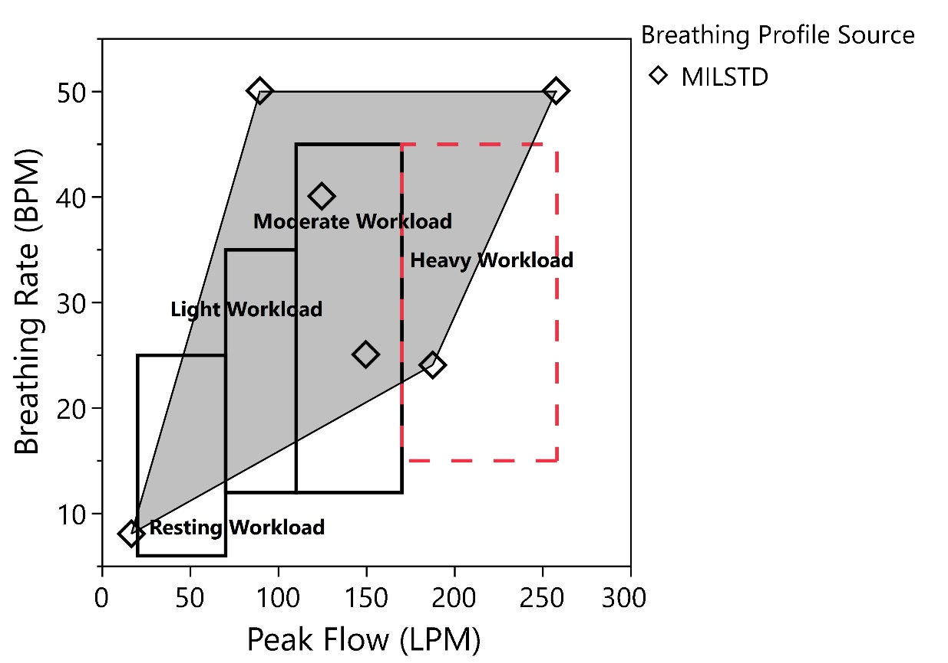
Figure 9: Comparison of MIL STD versus AIR STD Guidance

Comparison of Three Labs with MILSTD Guidance
Over the course of all of our testing, there were actually three separate laboratories that conducted tests. We compared these three labs to MILSTD test point selection: two US Air Force (USAF) labs and one contractor lab, each labeled as Lab A, B, and C. We worked primarily with Lab A, while previous test designs from Labs B and C were made available to us during the project.
Figure 10 shows the comparison of breathing profiles for the three labs and the MILSTD. The MILSTD points are represented by the diamonds while labs A, B, and C are represented by circles, triangles, and upside-down triangles, respectively. The shaded regions represent the test space covered by each lab: the lightest gray represents the test space outlined in the MILSTD, the darkest gray region represents that of lab A, the striped region represents that of lab B, and the medium gray represents that of lab C. There is no clear understanding why the labs selected their test points while other “mandatory” test points from MILSTD were left out. In particular, the breathing space region for lab A is particularly small. Lab A only uses four test points compared to the six used in the MILSTD. This lab also has a significant departure from the MILSTD, but attempts to cover the AIRSTD recommendations. The breathing profile space of Lab B (the striped shaded region) has seven test points and also varies from the MIL STD greatly, yet covers more of the desired test region. Lab C (medium gray shaded region) has similar breathing profiles compared to the MILSTD, with the exception of the test point in the upper right corner of the design region.
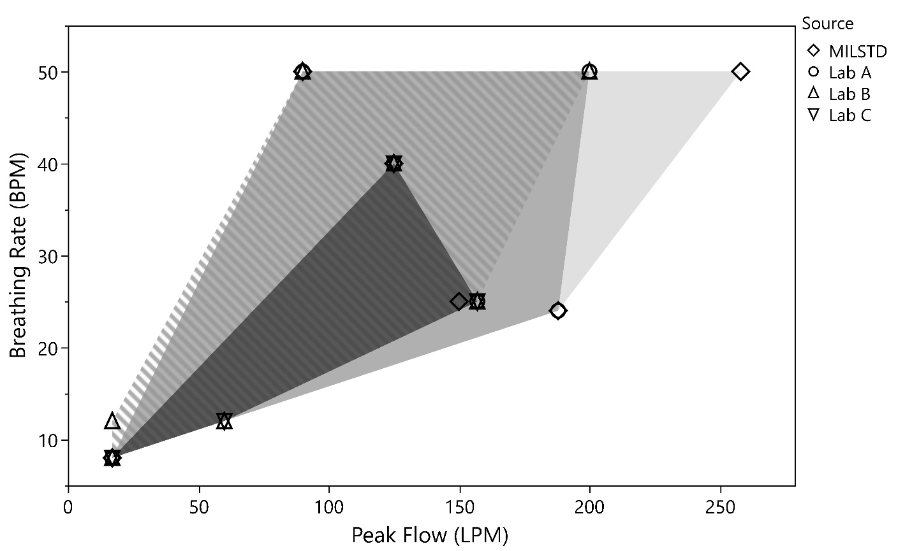
Figure 10: Breathing Profiles for each Lab
Finally, Figure 11 superimposes the design regions for the MILSTD, each lab, and the optimal design we created using JMP. After checking with our engineering SME, we have agreement, particularly because the bottom right corner, which had not previously been tested, had always been a (minor, but enduring) concern. Once this visual analysis demonstrates that corner test point is in fact on the edge of human Tidal Volume potential, it now becomes a necessary part of the safety of test issues.
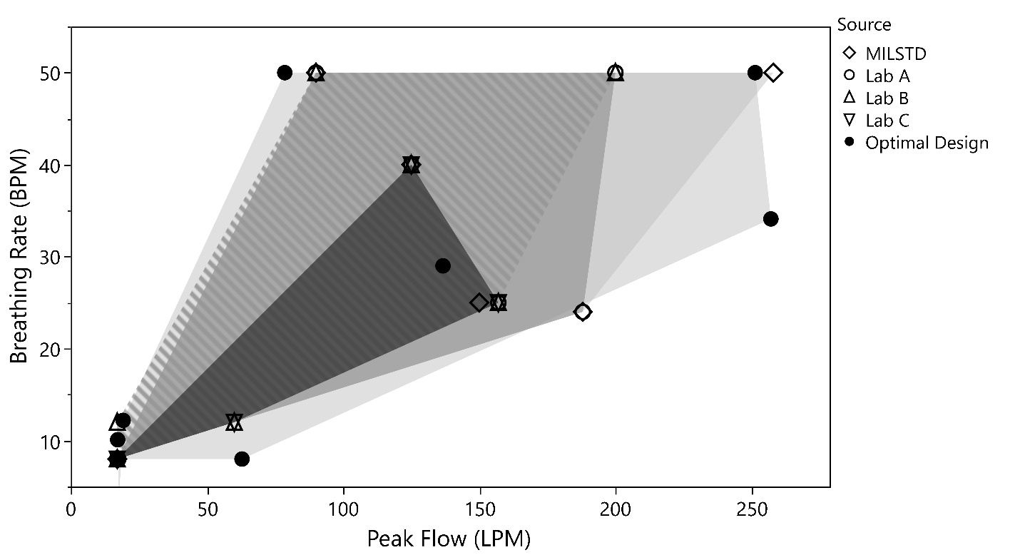
Figure 11: Overlaid Breathing Space Design Regions for MILSTD, Labs, and an Optimal Design
As you look at the regions each test potentially covers in Figure 11, ask yourself, “If I were the sponsor of the test and I knew this information, which set of test points would I want to form the foundation of my test design?” This begs for the MILSTD Appendix C table to be updated to include these points as the minimum for safety tests. Furthermore, it requires a better explanation of how to set up an appropriate test design to accomplish the objective of being able to determine to sufficient statistical confidence and power if an OBOGS is succeeding in meeting its design objectives or not. We strongly note and emphasize that it is not the case that government (and industry) testers are not professional, rather it is often the burden of time pressure placed upon the schedule that makes it difficult for the non-DOE practitioner to do the planning due diligence required to make sure a test adequately covers the appropriate test region for each factor that is the issue. It is this effort’s purpose to better inform practitioners and to clarify the requirement set forth in the MILSTD. Indeed, even the DOE practitioner can be subject to this pressure, but should fight it, being aware of the harm it can produce! Further, if statistics is not the core discipline of the lead tester (it may instead be engineering, for example, which is very common), it is unlikely this science-based testing approach will be employed.

Discussion
The failure of providing documentation for the “why” of these test point decisions is catastrophic due to inevitable changeover of personnel as test programs proceed year after year. It is also catastrophic to leadership checks and balances because when a program leader asks “why” of his “trusted” engineers, he will simply be told this is the way all the previous tests were conducted, and that should satisfy everyone; after all, if we select the same test points we relied upon before, and they were correct then, they must be correct now, right? Good scientific practice of questioning all assumptions is lost in the process, largely due to inadequate documentation of the factor level selection. This does not mean there were not good reasons to choose those points. They roughly mirror the “mandatory” guidance. But in doing so, without an independent decomposition of the system (including the factors) for each new test phase, we run program and performance risks of perpetuating mistakes from prior test efforts. The information gleaned and communicated in this paper is no exception.
Another open question concerns a valid range of tidal volume. The values of tidal volume recommended in the MILSTD ranged from 0.5 to 2.5 L. However, U.S. Navy in-flight testing analyses from the early 90s shows calculated tidal volumes reaching upwards of approximately 5.0 liters and under 0.5 liters for very short periods of time during flight (results from these tests shown in Figure 12. Gordge [1993]). These areas require additional consideration in determining the levels of tidal volume to adequately test the “safety zone” for unmanned testing of LSSs as defined in the MILSTD. Future efforts on a fast jet LSS should take into account the information gleaned from the Navy. This shifts the upper and lower limits of safe-to-fly tidal volume values that should be tested, and should change the appropriate and reasonable region for future tests, as should any in-flight data that indicates such appropriate values (Gordge, 1993).
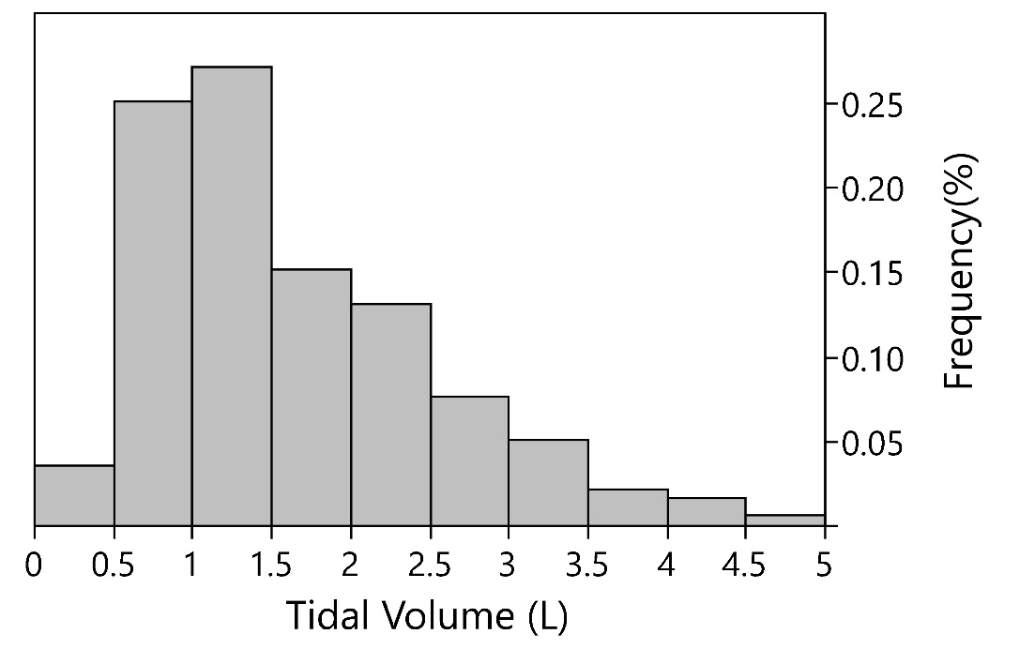
Figure 12. Tidal Volume Data from Navy In-Flight Measurements (Gordge, 1993)

Conclusion
If we were permitted to thoroughly engage in a forensic study of what could have been done better during the LSS acceptance testing, we are confident we would find pressures of time and money as root causes of poor testing. There was inadequate testing in the development and qualification of this significant LSS, particularly where the OBOGS concentrator control algorithms were concerned. It seems that once a testing regimen is deemed adequate (i.e., an initial qualification test passed years ago), inertial forces of business and sociology ensure there is comfort under pressure to continue to test “as we’ve always done it.” After all, the previous testing regimen was approved and deemed “successful.” But we do not agree this is the case with LSSs and is likely to be a problem in a large number of acquired systems and subsystems of complex machinery. This further highlights a critical element that is often ignored: the human element and biases inherent during all engineering development and testing. Our experience on this program exposed to us the entrenched mindsets that remain attached to ineffective and unscientific test methods and designs, particularly for defense applications. At best, practitioners unwittingly use these test designs to confirm what they already believe, and at worst, disastrously fail to answer the critical questions at hand. In the resource-constrained environment common to modern Department of Defense (DoD) acquisition programs, engineers and managers no longer have the luxury of years of time and enormous government test resources that allow teams to stumble into success.
A good test design begins with a clear understanding of the system under test and collaborations with system subject matter experts. Often this understanding involves constraints to testing. Statistical computer software enables rigorous test design and yields defensible results. Such statistical software capabilities combined with STAT processes enabled efficient and effective testing of a fast jet life support system to quickly get results. This paper highlighted some of the pitfalls practitioners may incur when developing such test designs and provides a test point template for how to setup a test across a constrained design space for future military fast jet life support system tests.
This knowledge should help prepare DOE practitioners with how to deal with stakeholders of the experiment who oftentimes are unaware of poor laboratory setup or discipline for testing. All stakeholders need to come to an understanding that successful outcomes for any test are limited to the extent appropriate data is obtained. Stakeholders should ensure all of the underlying assumptions to the testing approach are satisfied including randomization, replication, and local control of sources of variation.

References
Air Standardization Coordinating Committee. (1982, August 18). AIR STANDARD 61/101/2B. Development Test and Evaluation of Aircraft Oxygen Delivery Systems. https://assist.dia.mil.
Department of Defense Design Criteria Standard. (2015, May 11). MIL-STD-3050. Aircraft Crew Breathing Systems Using On-Board Oxygen Generating System (OBOGS). Retrieved from https://assist.dia.mil
Ernsting, J., Nicholson, A. N., & Rainford, D. (2003). Aviation Medicine, 3rd Edition. London: Arnold.
Gordge, D. W. (1993). In-Flight Measurement of Aircrew Breathing in Navy Aircraft. Technical Memorandum, Systems Engineering Directorate.
Montgomery, D. C. (2017). Design and Analysis of Experiments, Ninth Edition. Arizona: John Wiley & Sons, Inc.

