

Developing Unmanned Tests of Aircraft Life Support Systems:
A Case Study
June 2022
Wayne Adams, Contractor

DISTRIBUTION STATEMENT A. Approved for public release; distribution is unlimited.
CLEARED on 7 September 2022. Case Number: 88ABW-2022-0709

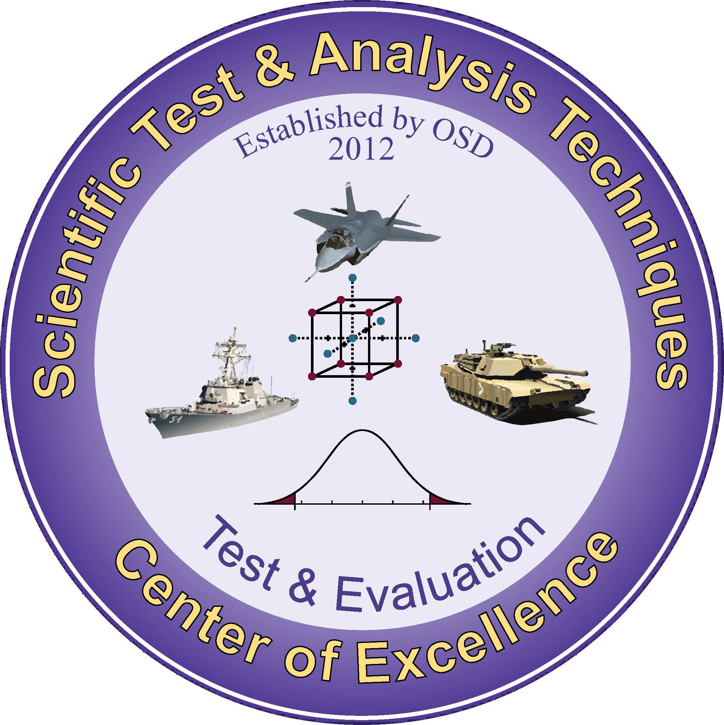
The STAT COE provides independent STAT consultation to designated acquisition programs and special projects to improve Test & Evaluation (T&E) rigor, effectiveness, and efficiency.

About this Publication:
This work was conducted by the Scientific Test & Analysis Techniques Center of Excellence under contract
FA8075-18-D-0002, Task FA8075-21-F-0074

For more information:
Visit, www.AFIT.edu/STAT
Email, CoE@afit.edu
Call, 937-255-3636 x4736

Copyright Notice: No Rights Reserved
Scientific Test & Analysis Techniques Center of Excellence
2950 Hobson Way
Wright-Patterson Air Force Base, Ohio

The views expressed are those of the author(s) and do not necessarily reflect the official policy or position of the Department of the Air Force, the Department of Defense, or the U.S. government.

Version: 1, FY22

Executive Summary

The National Defense Authorization Act for Fiscal Year 2022, Section 224 calls out a need to thoroughly test onboard oxygen generation systems (OBOGS) used in tactical fighter aircraft with a goal of fixing all discovered deficiencies. Unmanned laboratory testing of OBOGS at government facilities has traditionally been used to provide data for a test readiness review (TRR) leading to a recommendation to advance to manned testing. Manned testing is required for the final go/no-go decision. However, recent advances provided by new test facilities and modern scientific test and analysis techniques (STAT) will enable more complete, more cost efficient, and more effective unmanned testing of OBOGS than manned testing. Complete unmanned OBOGS testing results should be used to identify, characterize, and guide engineering decisions to fix deficiencies in OBOGS performance before manned testing begins.

Keywords: OBOGS, Testing, STAT, Modern, Aircrew Life Support

Table of Contents
Executive Summary i
Introduction 1
The STAT Process 1
Case Study 2
Applying Complete Testing 3
Lessons Learned 5
Test Planning 6
Test Design 7
Test Execution 8
Test Analysis 9
Conclusion 10
References 11

Introduction

Historically, unmanned tests of onboard oxygen generation systems (OBOGS) and other life support systems (LSS) focus on confirming a system can meet requirements or demonstrate that a failing system taken from an aircraft will continue to fail in a laboratory environment. Unmanned qualification tests (QT) must detect performance anomalies and characterize potential causes to determine if the system is safe for manned testing and operational employment. The use of the word “anomaly” as opposed to “deficiency” is intentional. A performance anomaly occurs when the system does not meet a requirement or MIL-STD based threshold under specific conditions, whereas a deficiency is an anomaly that is deemed unacceptable by a competent authority after further characterization. The proposed “complete test” method uses scientific test and analysis techniques (STAT) to design a series of tests to 1) completely cover the possible operation and mission space, and 2) seek to produce anomalies by challenging the system by going “slightly” beyond operational requirements while not damaging the system under test. Such a test requires: 1) rigorous planning to determine the definition of “slightly”, 2) follow-on analysis to confirm the anomalies, and 3) additional focused testing to characterize those anomalies and determine if they are deficiencies. Early characterization of anomalies found during unmanned testing will result in better planning for manned phases of test and can lead to a decision to fix and retest a deficiency before continuing. If complete unmanned testing is unable to detect anomalies, then assurance for mission suitability is improved and manned testing can be focused on further improving mission assurance.

This paper will
- present a case study using the complete test method,
- show how STAT is used to create more effective tests,
- show some of the limitations of testing implied by existing standards,
- discuss some of the gaps between test results and test goals that can be closed with complete testing during Qualification Tests (QT), and
- show how complete testing can result in early decision making and problem resolution.

The STAT Process

The STAT Process (Figure 1) is used to provide decision-maker rigorous, defensible, and repeatable results by guiding the collection and analysis of data using modern STAT to produce efficient and effective test designs. STAT is often thought of as traditional design of experiments. But, because Department of Defense (DOD) testing can be very complex, STAT has evolved into a series of tools to determine the purpose of the test and design a test plan to accomplish that purpose by providing decision-quality information. The four main elements of the STAT Process are 1) Planning, 2) Designing, 3) Executing, and 4) Analyzing. Complete testing focuses on detecting anomalies and determining their cause throughout the operational envelope. This case study focuses on life support systems, but complete testing methods are applicable to other systems. For more information regarding the STAT Process visit www.AFIT.edu/STAT, Guide to Developing an Effective Test Strategy_DistroA.pdf (afit.edu).

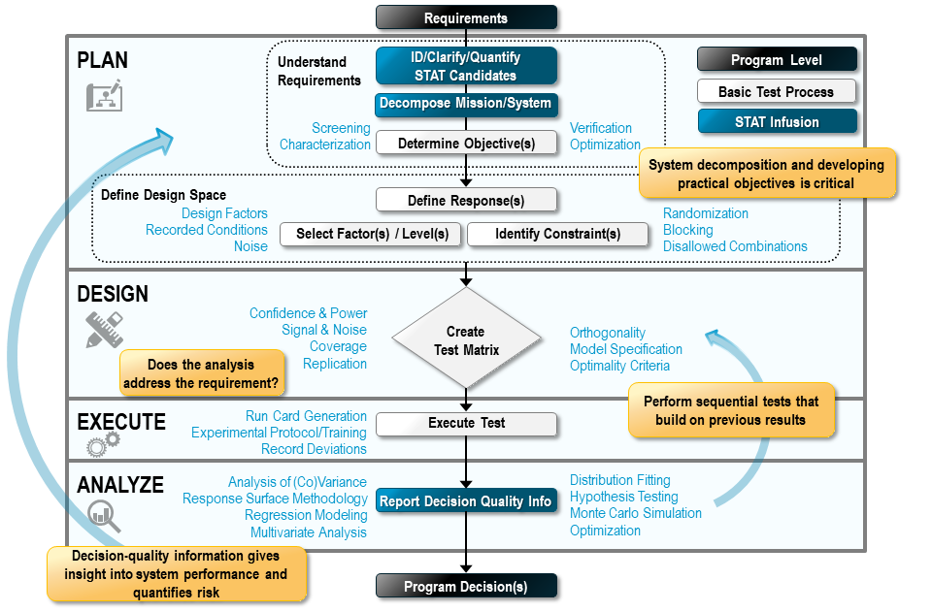
Figure 1
The STAT Process
Case Study

The following is a collection of ongoing work done at the Life Support Systems Scientific Test Analysis and Qualification (LSSSTAQ) lab on Wright-Patterson Air Force Base. The lab uses complete testing methods to provide decision-quality data more quickly to multiple customers rather than being dedicated to a single program at a time. Because of their equipment configuration and heavy involvement in the test planning phase with each customer, they are able to discuss the benefits gained from using complete testing methods.

The LSSSTAQ lab is comprised of three pressure chambers, two vacuum pumps, two breathing machines, a control room, and a suite of electronically linked controls, sensors, and support equipment. The lab uses the breathing machines to independently simulate up to two crew breathing profiles. One simulated pilot can be breathing hard, or even hyperventilating, while the other is calm and steady or both pilots can be in full recovery breathing. The combinations are not limited. Headforms of various sizes are used to test the mask fit and connection to the regulators. The altitude equivalent pressure can be independently controlled in each of the three chambers. Typically, only two are used to simulate the aircraft environment. One chamber simulates the aircraft environment where the concentrator, plenum, and back-up oxygen system (BOS) are located, while the other is considered the cabin which contains the regulators, masks, and breathing machines used to simulate pilot breathing profiles. The two chambers are typically run at a pressure differential where the cabin is generally at a higher pressure consistent with normal aircraft operation, but the differential can be set to zero to simulate a decompression event. The inlet air pressure used to operate the OBOGS concentrator is controlled to simulate aircraft environment control system (ECS) fluctuations and failures. Pressures, concentrations, and flow rates of the breathing gas are measured and reported at multiple locations along the system from the concentrator inlet to the regulator input and output and finally in the mask and throat of the headform. All measurements are recorded 20 times per second (20Hz). This frequency provides a nearly continuous picture of the state of the system and how it is interacting with the environment.

Applying Complete Testing
The Scientific Test and Analysis Techniques (STAT) Center of Excellence (COE) partnered with the LSSSTAQ lab to support the setup of the lab and to work in parallel with their customers’ test teams to develop the test plan, design the test, monitor the execution, and provide analysis. The lab personnel overcame challenges and produced useful data to guide decisions despite being a brand-new, partially-built facility when the first customers arrived.

Slowdowns in the acquisition and maintenance of necessary controls and test sensors resulted in limited work being done to characterize the input control and measurement capability of the lab. A full measurement systems analysis plan for the installed systems was recommended but not implemented due to a pressing need to begin testing for customers. The lab is relying on calibration records to ensure they have an effective measurement system. Due to the lack of measurement systems analysis, variation estimates were inflated to compensate for the lack of information regarding the capability of the measurement system.

Several dry runs were performed with unserviceable F-35 OBOGS along with other systems being considered for future use. This data was used to refine the test method and provide a better understanding of the limitations of the test facility. New customers will benefit from this work as complete testing provides a clearer picture of LSS operation than ever before.

The STAT Process begins with understanding requirements and refining them into testable thresholds and objectives. Unmanned qualification tests (QT) and operational tests (OT) of OBOGS systems should show that the system does or does not meet requirements by characterizing the link between OBOGS performance and critical input factors across the range of possible mission configurations, and then comparing the results to relevant standards and requirements. In unmanned testing, the list of factors primarily includes aircrew breathing profiles, aircraft altitude, altitude change, aircraft environment, and aircraft inputs supplied to the concentrator (bleed air, electrical current, etc.)
A breathing profile is a combination of waveform, frequency, and tidal volume. A common waveform used for LSS testing is sinusoidal. While not the same as human breathing, it is easy to use, and produces a known level of breathing flow direction, velocity, and acceleration. The sinusoidal pattern has been shown to be an effective method for testing breathing apparatus and is recommended in MIL-STD-3050, which provides six breathing profiles and is generally used to write the requirements for life support systems. However, as more research is done, MIL-STD-3050A is being revised to include four additional profiles. In both versions of the standard, the profiles were chosen to nearly match the pilot breathing observed during simulated flight, centrifuge training, and flight tests (NESC 2018). There is no indication these profiles will cause an OBOGS to perform poorly, but they have become the basis for testing. Because physiological events (PE) have been documented to occur across a wide range of pilot breathing (NESC 2018), the test team decided to cover more than the range implied by MIL-STD-3050 and expand testing to encompass the broader range of human capability (Figure 2). Complete testing fully covers a test region rather than specific combinations.
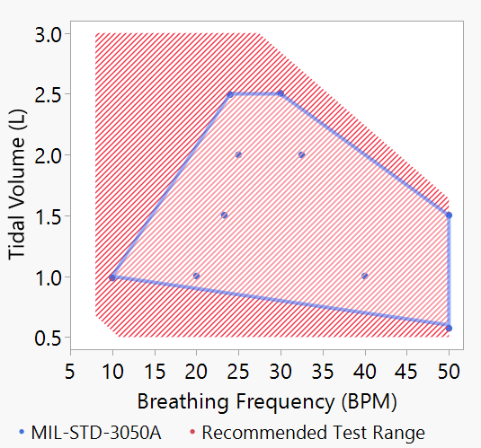
Figure 2
Breathing Profile Coverage
The same concept applies to altitude and altitude changes. MIL-STD-3050 calls out “ground level to the maximum ceiling” and “rapid ascent and descent.” PEs occur during and after level-flight, ascent, and descent. Altitude changes during actual flight range from gradual to extreme diving and climbing as seen during basic fighting maneuvers. The test team interpreted maximum ceiling to be the absolute altitude ceiling and designed the test to cover approximately 20% beyond the ascent/descent performance capability provided by the aircraft subject matter experts (SME) but also included small change rates and level flight.
Because the primary goal of QT/OT is to gain assurance that the system under test can fulfil the mission requirements, a rigorous complete test will push factors beyond thresholds but not beyond safe operation. This is done to better characterize the operational envelope of a system without damaging it. If testing is limited to only what is specified on the contract or in the requirements, the Government will lack an understanding of how variation in the field will affect the performance. Unmanned testing using a simulated aircraft environment is the best time to challenge a life support system, sub-system, or component. The cost is low, the risk is low, and most importantly any anomalies found can be immediately investigated, the contractor made aware, and later test phases informed. An anomaly that occurs due to the expanded space should be reported but should not be considered a deficiency without further investigation. This point was made clear to the test team; anomalies are not necessarily deficiencies, but they expand our knowledge of operational performance.
Another QT/OT goal is to certify that once the system goes to production, all subsequent units produced will also meet the requirements. But the standards do not specify how many systems need to be tested to ensure a rigorous decision. Unfortunately, a common practice designed to keep costs down, is to acquire a single demonstration unit from the contractor for all testing. Single units can be thoroughly and rigorously tested, but the Government is left to assume the single test article is representative of its entire population. When multiple test articles are tested in a batch, modern STAT does not require a completely new test for each one. Instead of increasing the test load four-fold for four test articles, a modern STAT approach will only increase the testing by about 50% (Table 1, comparing first to last column). Three and four test articles were used in this example but should not be taken as recommendation for future testing of new systems. The number of systems needed for a meaningful acceptance sample can be found in “Using Operating Characteristics (OC) Curves to Balance Cost and Risk” (Truett, 2018).

Table 1
Comparison of Test Matrices
Name/Design Type | Optimal | Optimal | Optimal | Optimal | Optimal | Space Filling
Factor | Concentrator Serials
Levels | 1 | 3 | 3 | 4 | 4 | 4
Model Supported | ME, 2FI, Q | ME, 2FI, Q | ME, 2FI, Q | ME, 2FI, Q | ME, 2FI, Q | Neural Net
Signal to Noise | 2.0 | 2.0 | 2.0 | 2.0 | 2.0 | 2.0
Confidence | 0.95 | 0.95 | 0.95 | 0.95 | 0.95 | 0.95
Total Runs | 84 | 117 | 120 | 132 | 144 | 130
 | 1 | 1.4 | 1.4 | 1.6 | 1.7 | 1.5
Whole Plots | 1 | 9 | 12 | 12 | 16 | 16
Power for ME | 100% | 100% | 100% | 100% | 100% | Discovers anomalies rather than fitting a model.  Better suited to purpose of OT.  Space-filling designs can be easily tuned to available budget. Whole plots are samples with replacement from the 4 concentrators
WP Power for ME | NA | 35% | 50% | 56% | 77%
Power for 2FI | 98% | 100% | 100% | 100% | 100%
Notes | Single Concentrator | 3 concentrators spread over 9 whole plots - need replicates | 3 concentrators spread over 12 whole plots - more replicates | 4 Concentrators spread over 12 whole plots - bigger sample from population | 4 Concentrators spread over 16 whole plots - bigger sample, more replicates

Several dry runs were performed with an old unserviceable F-35 OBOGS used in previous testing and a new OBOGS with permission of the customer’s program office. The data was used to refine the test method, better understand the limitations of the test facility, and inform future test planning sessions for new customers. Formal test runs likewise contributed to the lessons learned.
Lessons Learned
Chief among the lessons learned and reported to the test team was the BOS activated much more often than observed during development testing (DT) because the concentrator was unable to supply the required minimum oxygen during approximately 15% of the test. At this consumption rate the BOS would require two refills per day. Refilling the BOS bottle was time consuming and required an Air Force officer to transport the BOS bottle in a government vehicle to a private airport and pay for 99.5% oxygen concentration refills. Even if refills were more readily available this would be an unacceptable condition requiring a deficiency report.

Because the test plan made use of complete testing that took full advantage of the lab’s capabilities, sufficient data was gathered in the first few trials to begin characterizing this anomaly. Immediate analysis showed tests done at high altitude were very likely to result in BOS activation, whereas the low altitude tests, more representative of intended flight operations, would activate less often. Armed with the immediate analysis of the data, the test plan was modified to decompose the mission space by splitting the test into high-altitude and low-altitude sections. Limiting the altitude allows the lab to limit the BOS activation and be better able to plan for BOS refills. Providing quick analysis to inform follow-up test planning is a key feature of complete testing. It is also known as sequential testing or test-analyze-test.

Meanwhile, as the plan was being updated, the test team investigated the lab setup and practices. The investigation revealed that the concentrator exhaust configuration did not match the aircraft’s. A modification was made to the lab set up which fixed the BOS activation issue. After the fix was applied, the test execution was reverted to the original “all altitude” test and redone.
Had this anomaly not been forced to occur via challenge testing it is possible the entire test could have been conducted with a concentrator exhaust setup that was non-representative of the aircraft. The complete test could detect anomalies and establish a causal link between the anomaly occurrence and factor settings used in the test. Having this information enabled the test team to pursue both STAT (characterize and decompose) and engineering (investigate and fix) solutions. Had the investigation not found a special cause for the abnormal BOS activations, the statistical solution would have allowed the testing to continue and provide a thorough characterization to determine whether the BOS activation anomaly was indeed a deficiency.

Complete testing encourages pushing the limits of a system. Had the test team decided to follow a more tradition approach, where the altitude is limited to “normal operation” altitude envelopes, there would have been fewer and possibly no BOS activations. The anomaly could have been missed. Complete testing pushes systems into areas more likely to produce detectable anomalies. Anomalies produced in the challenge areas are used to better understand the performance limits of a system up to the edge of intended use. Complete tests that find no anomalies provide assurance to the decision makers the system will perform well–regardless of the mission. The LSSSTAQ lab can include complete testing in all of their test plans due to its ability to control the critical inputs and simulate the key components of the aircraft and aircrew, while providing real-time analysis of comprehensive data collection. Combining the complete testing method with the capabilities of the LSSSTAQ lab reduces the time to get from planning to analysis from weeks to hours.

Test Planning

Planning considers the entire test process with a focus toward enabling decisions by creating a test designed to close the knowledge gap and provide assurance to the decision makers. Well informed decision makers then determine if the system under test is able to meet performance requirements. Information about the LSSSTAQ lab’s capabilities, program requirements, additional test parameters, user-concerns, and test article limitations are combined with an understanding for what knowledge or level of assurance enables the customer to make a decision. The planning stage is generally the largest consumer of time throughout the test process. It takes so much time because everything is discussed, prioritized, and scheduled. The plan determines not only the end goals for analysis, but the route to get there. Once the requirements have been understood and turned into specific, unbiased, measureable objectives and thresholds that can be tested, the process shifts to determining what test facilities are needed, how much testing is necessary, and designing the most efficient and effective test. The LSSSTAQ lab, when provided a complete test article by a customer, only needs a short time to install, calibrate, and begin testing. The complete test method ensures that testing is focused on the end goal: make a decision to move forward to manned testing or go back to the contractor with a list of confirmed deficiencies.

Test Design

For modern test design, statistical software reduces the work of building multiple test matrices that are compared and contrasted as shown in Table 1. The key to success for the complete test method is a fast-flexible-space-filling design (FFSFD). The focus of the FFSFD is coverage to detect anomalies rather than power to detect effects. The Government already knows how a LSS is supposed to work; MIL-STD-3050 calls out a continuous pressure and oxygen concentration schedule as a function of altitude, breathing, and aircraft inputs to the LSS.

FFSFDs provide coverage over the entire allowable range of continuous input factors and across all levels of categorical factors. Traditional test designs pick test settings to provide the best estimates for polynomial coefficients or control the prediction variance. While traditional designs do provide some coverage, neither coverage nor anomaly detection is their purpose. Likewise, although, polynomial regression models can be fit to data gathered by an FFSFD, it is not their primary purpose. Because the complete testing method does not rely on detecting effects or fitting models, the FFSFD is more suited to detecting anomalies than more traditional factorial and response surface designs.

FFSFDs have the flexibility to be altered to fit the constraints of the system under test. They are able to incorporate disallowed combinations, categorical factors and directly manage the number of runs to ensure the design is fit to the problem rather than forcing the problem into a design. Disallowed combinations are used to limit the test region to where it is both possible and practical for the system under test to operate. As shown in Figure 2, high-breathing rate combined with high-breathing volume and low rate combined with low volume are not practical; the red-hashed area does not completely fill the independent limits of breathing rate and tidal volume. The technique is also used to control the flight envelope; the aircraft cannot ascend when it is already at the absolute ceiling, and it should not descend when it is at the operational floor. Typical categorical factors are used for equipment changes, such as, masks, regulator settings, multiple concentrators, etc.

FFSFDs used in the complete test method make use of the three primary STAT pillars for designing tests: 1) randomizing, 2) replicating, 3) blocking. These three concepts, when built into the design, provide the ability for the analysis to 1) mitigate, 2) estimate, and 3) adjust for uncontrolled variation (a.k.a. noise) that often occurs during tests (Adams et al.). These techniques do not make the noise disappear but provide valuable information to the analysis to build a more robust characterization.

By randomizing the order factor combinations are tested, an attempt is made to ensure the pattern of intentional changes to the factors do not match the patterns of noise. While there is no way to know the patterns do not match before the test is conducted, careful analysis can reveal if such problems have occurred.

Replicating some of the factor combinations is accomplished by redoing a particular combination at different time points during the test. Due to noise, it is unlikely that replicates will produce the same outcome. The difference in the outcomes is used to quantify the variability of the test. The quantified variability can be compared to the size of the effects in the model and to the variation around that model to determine the significance of the factor effects.

Blocking is used to compensate for nuisance variation coming from outside the test. For LSS testing, blocking is used for situations such as when the BOS runs out or end-of-day is reached before the end of the test. Randomizing altitude is a challenge because there is a need to get from one run’s ending altitude to the next run’s starting altitude. However, during this transition other factors can still be varied. Controlling other factors during the transitions effectively doubles the information provided by the test without using more test time.

FFSFDs require specialized software to build. For this case study JMP® Pro version 15.2 statistical software was used to create the base designs, the transition designs, and convert the test matrix into a control file for the lab to use. Figure 3 (left) shows the test plan without transitions, and Figure 4 (right) shows the included altitude transitions. Run 3 calls for a level flight altitude of 47,801 feet for 45 seconds, followed by a descent at 828.1 ft/sec for 40 seconds, resulting in an end altitude of 13,957 feet. Each dot shown on the figures is one second of test time.

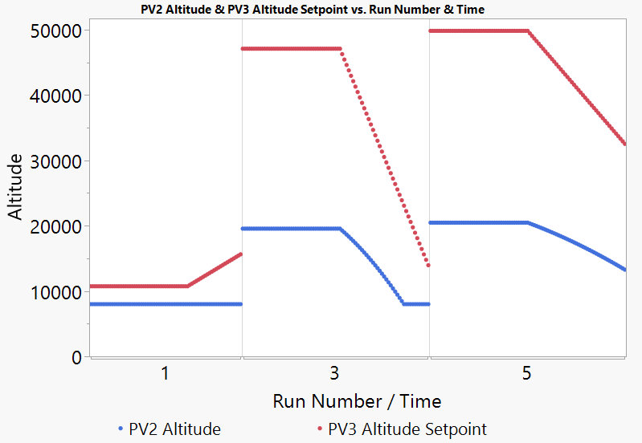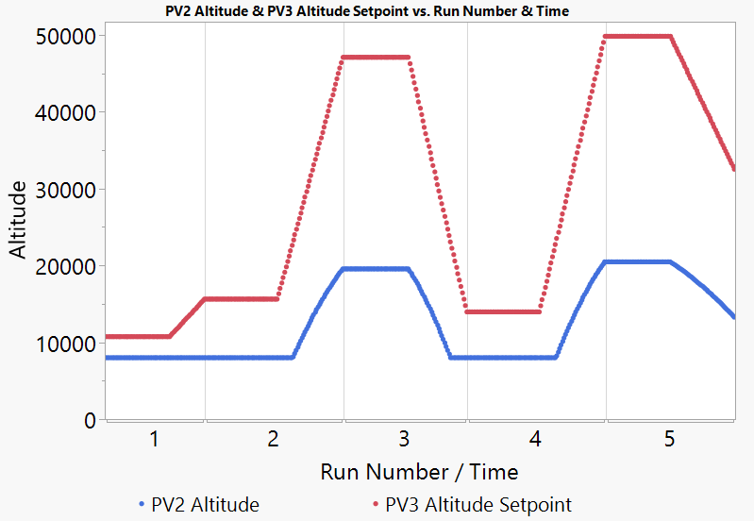
Figure 3 & 4
Randomized Altitude – With Transitions
Test Execution

Test planning is estimating the effort required, design is the process of finding the most efficient way to implement the plan, while execution is recording the effort expended and writing down the reasons for deviations from the plan and design. Test teams should be encouraged to design tests that allow for flexibility in updating the plan. Modern statistical software can build efficient test designs and minimize analysis time, giving time back to test teams to re-plan and re-design new test phases by taking advantage of what was learned. The fundamentals of test execution are also very important. Test facilities that are not observed often repeat old habits intended to keep costs down. It is best to discuss the effect that old habits have on the effectiveness of the test during initial planning, but it is also acceptable to document and justify these types of changes for the test team to review and approve. Alterations to test run order or factor levels should be approved before they are implemented.

The initial plan laid out by the lab, before the STAT COE became involved, was to test at five prescribed altitudes, using the six breathing profiles specified in MIL-STD-3050 at each altitude. There was no plan for randomization, replication, or blocking, but the planned durations of level flight were much longer. The chief engineer was interested in a more DOE-centric approach. The chief engineer requested some form of a screening test followed by robust characterization tests and then an optional response surface modeling test. A screening experiment’s purpose is to determine what factors have an effect on the critical responses. Robust characterization looks at how factors may interact with one another. Response surface work provides a detailed model of system performance across the range of factors in the test. These are commonly applied DOE techniques that would not have met the ultimate purpose of this type of test.

What was needed was a test to characterize system performance within and slightly beyond the operational envelope to determine where performance deviates from the requirements and which factor combinations are most likely to cause the performance deviations. The test must additionally be able to confirm system performance levels remain on schedule throughout possible operational space. The proposed complete test method is built exactly for these purposes. The space-filling design used has the flexibility to cope with lab and test article limitations, while thoroughly covering the range of operation.

Test Analysis

Detailed test analysis results are in a restricted distribution status. Interested parties may contact the LSSSTAQ lab. The following are some unrestricted synopsis results.

The largest and first customer to come through the LSSSTAQ lab was a full system OBOGS test. The goal of the unmanned test was to validate the contractor performance claims and certify the system was safe for manned testing. MIL-STD-3050 provided most of the threshold limits for meeting requirements. Anomalies were detected, but none of them were determined to be deficiencies. One of the lessons learned from this customer is the program office did not have a way to differentiate anomalies from deficiencies. When reporting findings back to the program and contractor members of the test team, a deficiency is something the contractor must fix, whereas an anomaly is something they can choose to fix or build into future design efforts. The anomalies were not intended to be the source of a failure determination, but to identify where a very strong system that performs well above requirements is “weakest”. This type of information must be collected and passed to future programs so these “weak” points can be improved as system requirements become more difficult to achieve. Anomaly detection analysis used exploratory data analysis, where graphs are created with multiple grouping techniques to see cause and effect relationships. This analysis provided the planning steps to build confirmation tests and better plan manned testing.

The second customer came to the lab to test the performance effects of an engineering change proposal (ECP) made by the contractor to allow them to use a more efficient manufacturing process. The program’s initial testing showed the new process did not create any material deficiencies. The purpose of the test at the LSSSTAQ lab was to show that the mask pressure performance was not affected by the engineering change. The test plan used the same style of space-filling design to cover altitude and breathing profiles as was used on the OBOGS testing.
Multiple masks from the ECP and current populations were made available for the comparison. Multiple individual mask tests introduce a hard-to-change factor. A hard-to-change factor is an input that cannot be fully randomized because the factor is difficult to change or cannot be changed without interrupting the test process. In the case of the LSSSTAQ lab, changing the mask on the headform requires the testing to stop, the pressure chamber door be opened, and the mask exchanged. Then everything can be resealed, pressures can be re-established, and testing can resume. Rather than randomizing a mask change each and every run, the mask is held constant for a series of altitude and breathing changes. Because the goal was to show the same distribution of pressure across each mask throughout a range of altitude and breathing changes, each mask was used multiple times providing replication. This protects against variation created by fitting issues and unknown sources of variation. Replication also provides enough information to perform a significance test to check if the masks are in different populations (current vs. ECP) are the same. The number of times each mask must be tested is a function of the size of the difference and the variability. Analysis consisted of removing the identified altitude and breathing effects leaving behind variation that could only be from random sources or caused by the masks themselves. An equivalence test was used to determine if the distribution of the mask-by-mask variation was not significantly different.

The last customer at the time of this writing was a new mask design. Similar to the ECP mask test, the customer was interested in determining if the new masks had similar, or potentially better performance than current in-use masks. The complete testing method was used to expose each of the new masks to a wide range of altitudes and breathing. Because complete testing was also used on the ECP program’s project, permission was obtained to reuse the current mask data rather than regathering new data. This saved quite a bit of time getting to the test report.

Conclusion

Complete testing provides the information needed by decision makers to make informed decisions. Building tests that can reveal anomalies provides a better understanding of the system under test irrespective of the requirements. The goal of unmanned life support system testing is to find anomalies and fix deficiencies before manned testing commences. Unmanned testing is cheaper, faster, and safer than attempting to cause a physiological event during manned testing or even flight. As demonstrated in this Case Study, the STAT COE recommends a more proactive approach, such as complete testing, to test life support systems and components to save the Government money, time, and most importantly–lives.

References

Adams, W. et al. (2020) Guide to Developing an Effective STAT Test Strategy V8.0. https://www.afit.edu/stat/statcoe_files/Guide%20to%20Developing%20an%20Effective%20Test%20Strategy_DistroA.pdf

Elliot, J., Schmitt, D. (2019) Unexplained Physiological Episodes A Pilot’s Perspective, Air & Space Power Journal, Fall 2019, 15-32. https://www.airuniversity.af.edu/Portals/10/ASPJ/ journals/Volume-33_Issue-3/F-Elliott_Schmitt.pdf

NASA Engineering and Safety Center, Technical Assessment Report, Volume I, Pilot Breathing Assessment, (2020). NESC Document #: NESC-RP-18-01320, Vol. 1 & 2.
https://www.nasa.gov/sites/default/files/atoms/files/nesc-rp-18-01320_v.1.2_nesc_pba_vol. _2_11-19-20_nrb_rp_final-.pdf

Natoli, C., Burke, S. (2018) Computer Experiments: Space Filling Design and Gaussian Process Modeling. https://www.afit.edu/stat/statcoe_files/Computer%20Experiments-%20Space%20Filling%20Designs%20and%20Gaussian%20Process%20Modeling.pdf

Simpson, J. (2014) Testing via Sequential Experiments. https://www.afit.edu/stat/statcoe_files/Testing%20via%20Sequential%20Experiments.pdf

Truett, L. (2018) Using Operating Characteristics (OC) Curves to Balance Cost and Risk, https://www.afit.edu/STAT/statdocs.cfm?page=1126

