

Female Body Armor:
Planning for Survey Success
January 2023
Gina Sigler, Contractor
Alex Christoffers, Contractor

DISTRIBUTION STATEMENT A. Approved for public release; distribution is unlimited.
CLEARED on 07 February 2023. Case Number: 88ABW-2023-0081


To develop and apply independent, tailored Scientific Test & Analysis Techniques solutions to Test and Evaluation that deliver insight to inform better decisions.

About this Publication:
This work was conducted by the Scientific Test & Analysis Techniques Center of Excellence under contract FA8075-18-D-0002, Task FA8075-21-F-0074.
For more information:
Visit, www.AFIT.edu/STAT
Email, AFIT.ENS.STATCOE@us.af.mil
Call, 937-255-3636 x4736

Copyright Notice: No Rights Reserved
Scientific Test & Analysis Techniques Center of Excellence
2950 Hobson Way
Wright-Patterson Air Force Base, Ohio

The views expressed are those of the author(s) and do not necessarily reflect the official policy or position of the Department of the Air Force, the Department of Defense, or the U.S. government.

Version: 1, FY23

Executive Summary

What does a successful survey look like? Survey success is highly dependent on the procedures used to both collect and analyze data. The main purpose of a survey is that the end results can answer the initial question posed. The STAT COE uses the STAT Process for many different Scientific Test and Analysis Techniques (STAT) including the design and analysis of surveys. For Female Body Armor (FBA), survey success is attributed to the cohesiveness of the team and the cooperation of all parties, which are critical enablers for effective survey planning and execution. This case study outlines for practitioners how the FBA team overcame the challenges of creating a problem statement, developing a quantitative comfort metric, and collecting a random sample. While it is understood that each program will be different, the underlying framework presented here can be used for any program that is looking to use a survey.
Table of Contents
Executive Summary i
Introduction 1
Methods: Overview of Study 1
Plan 2
Design 3
Execute 4
Analyze 5
Survey Challenges 5
Documentation of Goals 5
Quantitative Comfort Metric 6
Sampling Options/Administration 6
Lessons Learned & Survey Success 6
Traceability of Assessment Objectives 6
Comfort Metric Calculation 7
Analysis with Question Differences 8
Conclusion 9
References 10

Introduction
This case study demonstrates how the STAT Process can be used to effectively design and implement a survey in a program. The main steps of plan, design, execute, and analyze were followed throughout this case study, but were tweaked to match the needs of the individual program. While it is understood that each program will be different, the underlying framework presented here can be used for any program that is looking to use a survey.

The Female Body Armor (FBA) program was tasked with finding an available Commercial Off the Shelf (COTS) armor system that would have the proper form, fit, and function while still providing protection for female Air Force security forces. As part of this tasking, the FBA program needed a survey to evaluate how the current armor supported the needs of female security forces as well as measure how each of the potential new armors compared to the current vest system. To do this, the FBA program partnered with the Scientific Test and Analysis Techniques Center of Excellence (STAT COE) for their test and evaluation efforts. While additional testing was conducted, this case study focuses solely on the creation, implementation, and analysis of a survey that was administered to female Airmen. The largest wins took place during the planning phase of the STAT Process, which set the rest of the effort up for success.
Methods: Overview of Study
The STAT COE began by walking the program through the STAT Process (Figure 1). While, at the time, the STAT Process had not been typically applied to surveys, it was applied through the steps of plan, design, execute, and analyze (Adams et al., 2020). Planning a survey begins with the development of a problem statement that will drive the overall experimentation. This type of planning should lead testers to two activities: 1. develop a research question (or questions) that need to be answered, and 2. determine the target population to which the survey should be distributed.
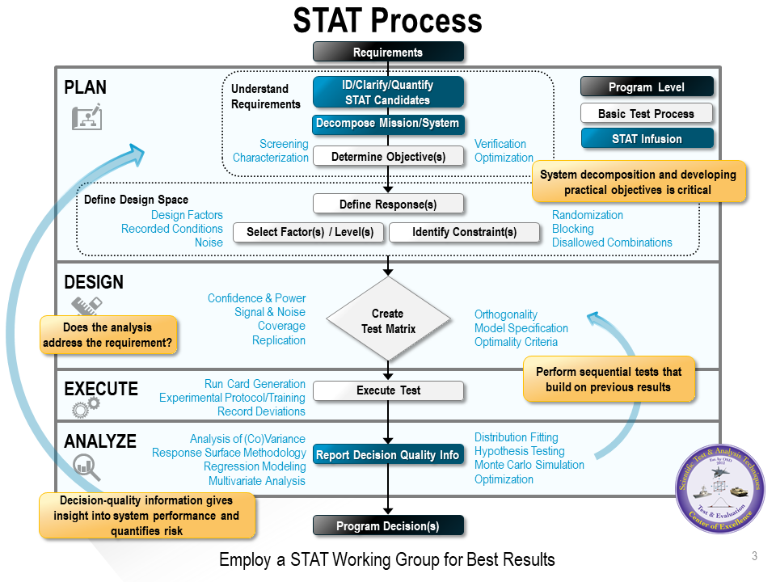
Figure 1
STAT Process
Designing a survey is different than creating a test design in terms of the metrics that are used. While factors and responses are still considered for the survey, they are both posed as questions to the respondent that must be collected. Two of the biggest survey metrics are bias and the length of a survey, which will influence the response rate received from participants. Sample size for a survey is based on how many responses you expect to get back from participants. For FBA, we expected to get a survey response from each person surveyed although depth of responses could still be impacted by survey length. However, this makes the sample size calculation much easier than the typical survey that would experience non-response bias (Tomlin et al., 2019).

Survey execution involves the collection of survey responses. In this case, this involved test personnel traveling to collect measurement information in addition to distributing the surveys. Finally, the analysis is conducted on the survey responses using the analysis methods that are outlined during the planning phase. For surveys, descriptive statistics are informative and can always be calculated (Tomlin et al., 2019). We also used principal components analysis and other methods to calculate the desired metrics.

Plan
Planning is the most important step of the survey process, as it is with most test processes. The STAT COE first integrated with the program during the requirements writing workshop, which was an excellent time to become involved. This tied in well with the first step of the STAT Process: Understand Requirements. While there were many requirements listed for the program overall, not all of them were applicable to the creation of the survey. To streamline the process, the team developed a problem statement to codify the reason for testing and create consistent vocabulary between the team. The problem statement for FBA is seen in Figure 2.

Female Airmen are in need of equipment that will be modular, scalable, provide suitable protection, and an acceptable level of function without sacrificing an appropriate level of comfort. This will optimize protection, mission effectiveness, and performance. Comfort refers to having a proper fit that will decrease the long-term medical risks to the Airmen relative to the current systems.

Figure 2
Problem Statement for Female Body Armor Program

After the creation of the problem statement, the team created a series of five goals. The goals were created using action verbs that would allow for the team to clearly understand when they had been appropriately answered. While the goals were broad to encompass the whole testing effort, the team also developed a research question that was specific to the survey itself. This focused the scope of the survey to a single target.

Instead of the typical decomposition phase of the STAT Process, the next step for survey design is to identify the target population. In this case, the target population was all female Airmen. Then, the team determined what information was needed to answer the research question. The FBA team expressed a desire to collect information regarding their current vest system on the following:

- Body shapes – humans come in different shapes and sizes
- Temperature – under vest, while wearing body armor
- Vest types – each vest type worn by participants
- Tiers – this is the levels of protection provided by vests; changed by adding or removing pieces and covering additional areas
- Weight – weight of the vests themselves
- Missions – missions to be completed while wearing the vests
- Comfort – the ultimate comfort level each participant has in the vests

This information was then categorized into responses and factors respectively for the initial and follow-on surveys depending on how the analysis was planned. The desired analysis method should be considered throughout the planning phase to ensure the appropriate data is collected for that methodology. It is also possible that the survey is incapable of capturing all the necessary information and an alternative data collection method is needed. In this case, the analysis methods accounted for correlated questions and the comparison of multiple surveys.

Design
The design of a survey is very different than that of a typical test design. Survey design is based around the previously defined research question instead of test objectives. Design metrics considered are survey length and bias instead of the usual power and confidence. It’s important to keep the survey a reasonable length or respondents may be unmotivated to complete it. Survey questions are developed with unbiased, precise wording to ensure respondents interpret the questions as intended and the intended data is successfully captured. The verbiage should be neutral to avoid positive or negative bias and the questions should not lead the respondent to choose a certain response. Questions should be clear, concise, and tailored toward the target population. When possible, it’s a good idea to test your survey with a small focus group to determine whether the questions are being interpreted how you intended and try to identify any areas for improvement before distributing to a larger sample.

The FBA team created demographic, Likert scale, and open-ended questions. Demographic questions provided descriptive information of the respondents that were surveyed. Fifteen Likert scale questions were utilized to gauge respondents’ attitudes, or feelings, regarding their current armor system on an ordinal scale from 1 to 5. Each rating scale included both the numbers and the corresponding words to avoid ambiguity. The response scales were to preclude the respondent from skipping the question or selecting a response that isn’t accurate. The team was very purposeful in their wording of the questions to avoid bias and allow for true neutral responses. For example, the five-point scales used for comfort level ranged from very uncomfortable, uncomfortable, neutral, comfortable, and very comfortable. We also allowed participants to be more specific on certain questions by providing diagrams for them to circle uncomfortable areas as seen in Figure 3. These questions were still quick to answer and could be easily described by the analysts for descriptive analysis.

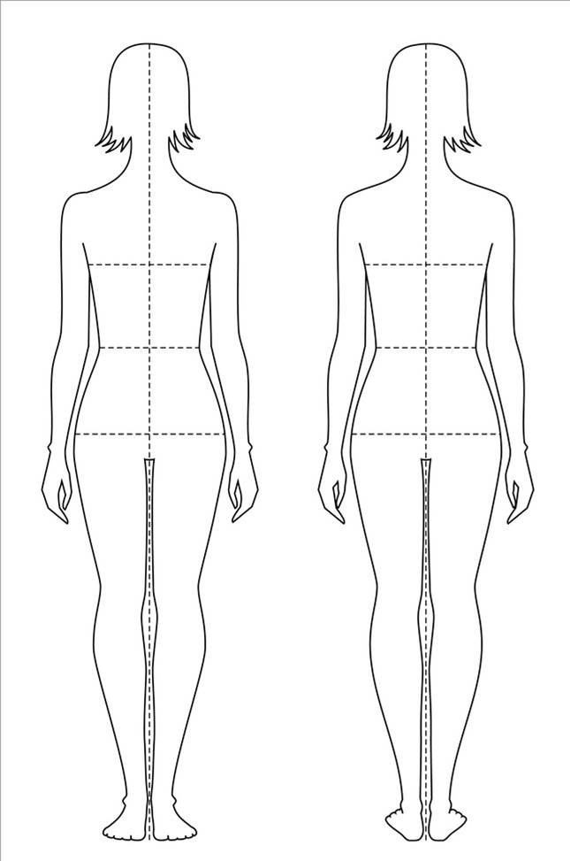
Figure 3
Survey Body Diagram

Lastly, the survey included open-ended questions. Although open-ended questions are difficult to analyze, they allowed respondents to share opinions or insights the FBA team had not originally considered. Open-ended questions provide supplementary information that can inform researchers. The overall FBA survey consisted of 27 questions (including demographics but excluding measurement data), which took approximately 5–10 minutes to complete.

Each question served a specific purpose and could be traced to a planned analysis method. For the Likert scale questions, a repeated survey for each of the potential COTS systems was administered and overall scores were compared to the baseline. Thus, the survey was designed for ease of analysis and to support the research question. For more information on the proper development of survey questions please see The Survey Research Handbook (Alreck & Settle, 2004).

Execute
Execution of a survey is all about the sampling method used to collect the data. Ideally, a random sample from the target population should be selected to complete the survey. Here, the target population was all female security forces. A random sample is a sample in which every unit within the population has an equally likely chance of being selected. This ensures the sample is representative of the population. A random sample is generally difficult to accomplish for many reasons: one reason is that an individual cannot be forced to complete a survey. As a result, non-response bias could negatively impact the data. Our sample consisted of female security forces from Minot, Moody, and Wright-Patterson Air Force Bases. Although the sample was not truly random, we had no reason to believe it was unrepresentative of all female security forces in the Air Force.

The women from the three bases were administered the survey by an interviewer. Interviewers were both male and female. Unfortunately, this introduced potential bias to the data as different interviewers could have asked the questions differently or respondents could have responded differently to a particular interviewer. Consistency is one benefit to written surveys as a data collection tool but incorporating numerous interviewers into the process disrupts that consistency. However, the interviewer ensured that each participant was completing all the survey questions. While the participants were elected to participate, we also found that most were excited to be participants as they were interested in being a part of the process of choosing a new body armor. Typically, we would want to account for which interviewer conducted the survey in the analysis, but this information was not recorded. Instead, we ensured interviewers were randomly assigned to interview each survey participant for each iteration and did not see any major impacts on the analysis.

Analyze
The desired analysis method should be considered throughout the entire survey design process. Otherwise, the data collected may not be able to answer the research question or feed the analysis needed to support the decision. The type of analysis the researcher wishes to conduct directly impacts the design and execution of the survey including question type and sampling method. Each question serves a purpose and is designed with a particular analysis method in mind that will be used to analyze the data.

Descriptive statistics can always be performed on survey data because they do not rely on assumptions, unlike other statistical analysis methods. Descriptive statistics are quantitative and graphical summaries of the sample data. They describe the sample. Descriptive statistics are part of the exploratory data analysis phase and help gain a better understanding of the data collected. Examples include the mean, median, mode, standard deviation, histogram, box plots, etc. A specific descriptive statistic used for the Likert scale questions of the FBA survey was proportions. This allowed the program to see the proportion, or percentage, of women who responded to a particular item below or above a certain level (e.g., 85% of women rated the comfort of their existing body armor as a 2 or lower).

Other types of analysis methods vary from survey to survey. FBA used two methods called Principal Components Analysis (PCA) and Factor Analysis to reduce the dimensionality of the questions. Further details on the specifics of this analysis are discussed in the Lessons Learned & Survey Success section. Additional information about analysis methods that are appropriate for surveys can be found in the STAT COE best practice Survey & Questionnaire Design (Tomlin et al., 2019).

Survey Challenges

Documentation of Goals
One of the common challenges that teams face when building surveys is the documentation of common language and goals. The documentation of the test goals is very important for a survey, as well as to typical experimental design, so the scope of the survey does not become a burden to the participants. It is well known that a longer survey is less likely to be completed by participants. Thus, it was very important that the survey retained focus on a few key goals that would be unable to be accomplished through traditional test or analysis methods. The FBA problem statement, seen in Figure 2, was broken down further into a set of five assessment goals:

- Recommend the best fitting and best value solution for our female defenders given the schedule and procurement constraints
- Clarify and evaluate the limitations of the currently used body armor systems and compare to other potential systems
- Characterize the relevant mission environments in which the current body armor systems are used
- Characterize the current issues with the armor used including, but not limited to, physical problems, trade-offs between all the current systems, and interference with mission tasks
- Characterize the impact of size and shape variation of the female defenders on the function and fit of the body armor; this includes identifying if there are some sizes and shapes that do not fit in the body armor for proper function
It was clear from the beginning that the survey would not be able to address all the goals, as this would require the survey to be too long. Thus, the team had to decide what survey questions would best reach each of the goals.

Quantitative Comfort Metric
The largest challenge for this survey was the creation of a quantitative comfort metric. While many responses such as temperature, movement angles, pressure, and heart rate are easy to measure, there was no industry standard way to measure the “comfort” of body armor. Instead, we created a series of questions that targeted elements of comfort:
- Please rate your overall comfort level while wearing this system.
- Please rate the level of chafing/rubbing you experience while wearing this system.
- Please rate the load distribution of this system.
- Please rate the ability of this system to dissipate heat.
While this list is by no means exhaustive, it did give a stepping-off point to create a quantitative comfort metric.

Sampling Options/Administration
Another challenge was the method for data collection of the survey. Typically, written surveys are sent out to participants, which can lead to non-response bias. In this case, the test required specific measurements from each of the participants. This meant the FBA team had to have personnel in place with the survey participants and limited how sampling was conducted. Instead of doing a random sample of female Airmen from across the bases, personnel were sent to only three bases. We were forced to assume that the participants from these bases accurately represented the female Airmen across all bases.

Finally, the draft survey was used in place of the final constructed survey to assess the current armor system. This was a problem as the draft survey was longer than the 5–10-minute survey we had intended. Also, we intended to have each participant fill out a survey for their current body armor as well as each COTS armor system they tested. The planned analysis method would use the repeated questions from each participant to compare the current body armor to each of the COTS armor systems. If the wording of the questions are not the same, then participant answers may not match and analysis may not be valid.

Lessons Learned & Survey Success

Traceability of Assessment Objectives
Arguably, the most important win was the development of the breakdown of the problem statement at the beginning of test planning. A problem statement allows the team to document what is driving overall experimentation and explain why testing needs to be done. This helps to justify the use of specific metrics or later split the testing into small goals such as those accomplished by a survey versus those accomplished by the physical fit testing.

While the requirements for a system are a great starting point, they may be difficult to interpret or directly test. Instead, we decided to develop a test structure that consisted of a problem statement, broken down into goals, further broken down into testable questions/assessment objectives. Table 1 shows the traceability of each assessment objective. Each objective is mapped back to the requirements (Key Performance Parameters [KPPs] and Key System Attributes [KSAs] in the table), goals, and the responses that will ultimately be used to answer the question. This documentation and team agreement ultimately enabled the justification of decisions at the end of the assessment. For future survey planning, we recommend having similar methods of traceability for your team to ensure cohesion.

Table 1
Traceability Matrix for Objectives, Requirements, Goals, and Responses

Assessment Objective | KPP/KSA | Goals | Measurable Response
Are the people currently fit properly for their vests? | KPP 5 | 1,2,4,5 | Chafing scale  Body measurements
Are the sizes available adequate to fit the central 95% of the population? | KPP 5 | 1,5 | Coverage
How does weight distribution affect comfort in worn vests? | KPP 3, KSA 1 | 2,4,5 | Heart rate  Pressure  Center of gravity  Ranking of comfort importance
How does the system affect the mobility of the wearer? | KPP 1 | 2,3,4,5 | Movement  Accuracy  Ranking of comfort importance
How does the system configuration affect the thermal burden? | KPP 5, KSA 2 | 2,4,5 | Temperature  Ranking of comfort importance
How are the vests impacting the different mission types? | KPP 6 | 3,4 | Accuracy  Response time  Movement
Does the system meet all user requirements? | KPP 2, KPP 4, KSA 3, KSA 4, KSA 5, KSA 6, KSA 7, KSA 8 | 2,3 | **completed by initial down selection**

Comfort Metric Calculation
One complication to the calculation of the comfort metric is the correlation between questions. FBA was interested in asking about several topics related to the comfort of the vest such as breathability, load distribution, and chafing. As mentioned previously, all these questions contribute to an overall measure of “comfort” for the system. In a typical analysis, all measured values are assumed independent. This is not the case with survey data. Instead, we had to use techniques to create uncorrelated variables.

Principal Component Analysis (PCA) is a dimension reduction analysis method that replaces correlated variables with fewer uncorrelated variables called components. In other words, survey questions that are similar are grouped together in a single component to reduce the number of overall variables. The individual components retain most of the information from the original variables and each one accounts for a portion of the total variation. The first few components will account for most of the variation; therefore, the other components can be discarded. PCA is part of exploratory data analysis and will not produce a statistical model.

Factor analysis is an analysis method used to analyze latent variables. Latent variables are unobservable and cannot be measured directly. An example of a latent variable is comfort. To measure a latent variable, data is collected from observable variables that are suspected to be indicators, or strongly associated, with the latent variable of interest (Bartholomew, 2008). Observable variables make up each uncorrelated factor and that factor represents a latent variable, or an unobservable variable. Unlike PCA, factor analysis will result in a model. However, the interpretability of the model is difficult.

Both methods were planned for use in the data analysis for FBA. We used PCA as well as factor analysis on the questions to see if any of the sets of questions created a natural comfort metric that could be used for future predictions and models. These methods were successful due to the previous planning and the way that the questions were recreated using subject matter expert (SME) input. This was only possible due to team input during the creation of the survey.

Analysis with Question Differences
Finally, we tackled the issue of differences in survey questions between the draft survey (implemented) and final constructed survey (intended). Once we realized the draft survey had been used to assess the legacy system, we had the opportunity to adapt it for the additional COTS systems. For the COTS armor systems, the draft survey was shortened, and some of the questions were altered to have similarly worded questions so that comparisons could be made. The goal was to create more generally worded questions while keeping the survey short. The original and changed questions can be seen in Table 2.

Table 2
Survey Question Mapping Table

Original Question | New Question
Q8: Please rate your ability to raise your arms above shoulder level in the vest. | Q1: Please rate your ability to move your arms in motions normally required while wearing this system.
Q12: Please rate your comfort while wearing the vest standing. | Q3: Please rate your overall comfort level while wearing this system.
Q22: Please rate the level of chafing/rubbing you experience while wearing the vest. | Q4: Please rate the level of chafing/rubbing you experience while wearing this system.
Q10: Please rate your ability to operate a vehicle while wearing the vest. | Q5: Please rate your ability to operate a vehicle while wearing this system.
Q21: Please rate the load distribution of the vest. | Q8: Please rate the load distribution of this system.
Q20: Please rate the breathability of the vest. | Q9: Please rate the ability of this system to dissipate heat.
Q26: Please rate your overall satisfaction with your current vest on a scale of 1-5. | Q10: Please rate your overall level of satisfaction with this system.

Using both the current body armor surveys done at Minot, Moody, and Wright-Patterson Air Force Base and the follow-up surveys done on the COTS armors, questions were matched, and the proportions of favorable (those who responded 4 or 5 on the survey) responses analyzed. Pairwise chi-squared tests for equal proportions were run on each question set. P-values from these tests were then compared to a pre-determined alpha level. The survey was successful due to the insights that were gained from this analysis, showing that the COTS systems were preferred over the current body armor. For more information on p-values, alpha levels, or other statistical methods, please see the Guide to Developing an Effective STAT Test Strategy V8.0. STAT COE (Adams et al., 2020).

Conclusion
This study serves as an example of how to properly create and analyze a survey using the STAT Process. The plan, design, execute, and analyze steps were used to overcome each of the challenges posed by the program. The study also highlights how important the planning is to the success of the survey overall. Without proper planning, there would have been little chance the analysis results would have yielded the proper insights. While it is understood that each program will be different, the underlying framework can be used for any program that is looking to use a survey.

References

Adams, W., Burns, D., Burke, S., Divis, E., Harmon, M., Jones, K., . . . Truett, L. (2020). Guide
to Developing an Effective STAT Test Strategy V8.0. STAT COE, Department of
Defense. Air Force Institute of Technology.

Alreck, P. L., & Settle, R. B. (2004). The Survey Research Handbook (3rd ed.). McGraw-
Hill Irwin.

Bartholomew, D. J., Stelle, F., Moustaki, I., & Galbraith, J. I. (2008). Analysis of Multivariate
Social Science Data (2nd ed.). CRC Press.

Tomlin, S., McBride, A., & Sigler, G. (2019) Survey & Questionnaire Design. STAT COE,
Department of Defense. Air Force Institute of Technology.

