System Decomposition Worksheet
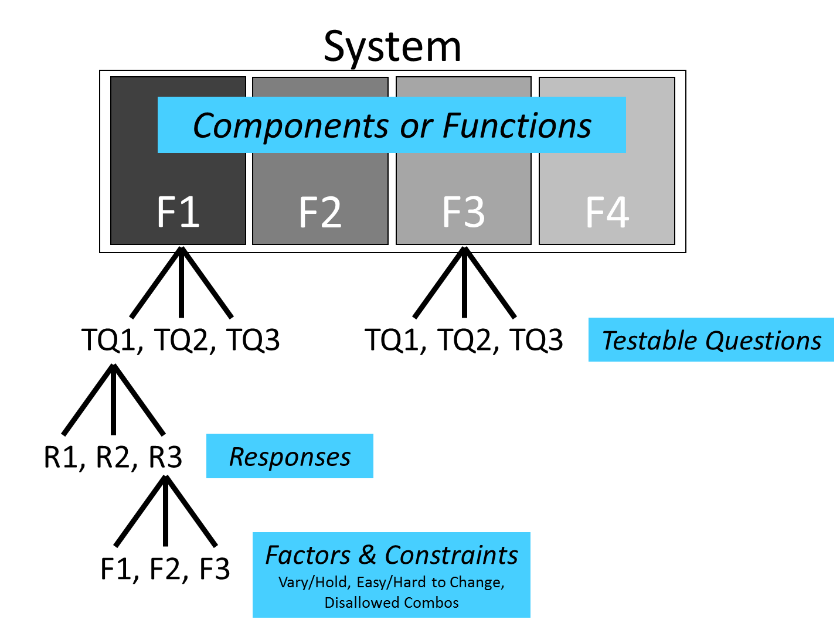
System Decomposition: Decompose your (sub)-system into its functional components

Defining the Objectives/Testable Questions: Should be specific, unbiased, measurable, and of practical consequence
These are the testable questions you will answer by executing the test(s) on your system. Note: A function/component may have more than one test objective associated with it
Function # | Description | Requirement  (KPP, KSA, etc.) | Testable Question | Objective Type
Objective/Testable Question Types: Characterize, Screen, Optimize, Compare, Confirm, Discover, Robustness

